Contents

All Components Working 4

Can login and access to Cognos Connection (Web Portal) 4

Packages installed Access to GO Sales and GO Data Warehouse packages – 5

Dispatcher URI for Gateway 5

P2plbDiag Screen capture ( File is provided with Submission) 6

All Dispatchers are active from portal 7

Firewall Rules 8

Inbound firewall rules 8

Outbound firewall rules 8

Reports Running successfully 9

• Report 1- 2011 Sales Summary “ From sales Package “ 9

• Report 2- Budget_vs_Actual by Retailer “From DW Package “ 9

ADLDS 10

• ADLDS Configuration in CM1 10

• ADLDS Configuration in CM2 11

• ADLDS Directory 11

Basic Security 13

Allow Anonymous Access No 13

Restrict Access to members of the built-in namespace 13

Unauthorized user ( Cognos User1 – Not allowed to login) 14

Third Party Components 14

1) SunLDAP Connection 14

• Log IN Screen 14

• Sun-LDAP Configuration in CM1 15

• Sun-LDAP Configuration in CM2- 15

• Users in Sun-LDAP 16

2) Audit DB Connection 17

• Audit DB in MSSQL 17

• Audit DB Configuration in CM1 18

• Audit Configuration in CM2 18

• Audit DB Configuration in App1 19

• Dispatcher Logging to **basic** 19

• Audit Package installed 20

• Running a report from the Audit Sample (Logon operations by User Name) 20

3) SMTP 21

• Notification Configuration in App1 21

• Notification Configuration in App2 21

• Notification Configuration in CM1 22

• Notification Configuration in CM2 22

**Mail for evidence:** 23

• Sending an email 23

Email Sent Successfully Carlos VM-Email Message Received sent from Ahmad user ( LDAP) 24

APP1- tuning 25

APP2- tuning 25

Load balancing: Application Server 26

After Running multiple Reports - 26

App1- performance metrics 26

App2- performance metrics 27

Content Security 29

Cognos Administration 29

Great_outdoors_warehouse - Permissions 29

GoData Warehouse Group 29

GoDW-Admin – members 29

GoDW- Read – members 30

GoDW- Read Execute – members 30

Great_outdoors_sales – permission 30

GoSales-Admin – members 31

GoSales - Read – members 31

GoSales - Read Execute – members 32

GoSales - All users – traverse members 32

Cognos Connection: 33

Public Folder permissions 33

Go Data Warehouse Query - permissions 33

Go sales query - permissions 34

Go sales Analysis permissions 34

Go Data Warehouse Analysis Permissions 35

Only the appropriate services are running on each of the components. For example: 36

Front Dispatchers only runs the services it requires to perform its functions. 36

FD1 Services: 36

FD2- Services 37

Query services disabled on all components. 38

Query services disabled – App1 38

Query services disabled – FD1 39

Application servers do not run the Presentation Services. 39

APP1- Services 39

APP2- services 40

Fault Tolerance – 4 points 41

Both CMs need to be configured identically such that they enforce the same level of security and offer the same name spaces for authentication purposes. 41

Fault Tolerance : Content Manager 41

P2plbDiag with CM1 down and Cm2 up 41

P2plbDiag with CM1 recovering ( CM2 is the active CM, Cm1 is the Standby) 44

Fault Tolerance : Front Dispatcher 45

P2plbDiag with FD1 down, FD2 is up 45

FD2 is the active front Dispatcher 45

System is working, FD1 is unavailable 46

CM1 & CM2 Same functionality and security 47

CM1 Configuration: 47

CM2 Configuration: 50

Basic Security – 4 points 54

Documentation – 2 points 57

Print the system specs summary: 57

Print a copy of your logical architecture diagram 58

Please provide the list of LDAP accounts. 59

• Users in Sun-LDAP 59

Print a copy of the hosts file for the CM and FD. 60

CM1 Hosts file 60

CM2 – Hosts File 61

FD1 Hosts File 62

FD2 Hosts File 63

# All Components Working

## Can login and access to Cognos Connection (Web Portal)

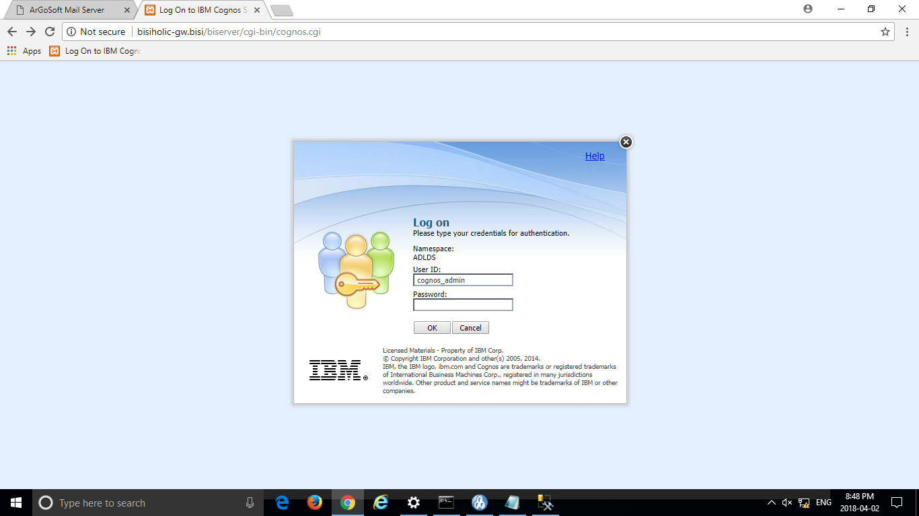

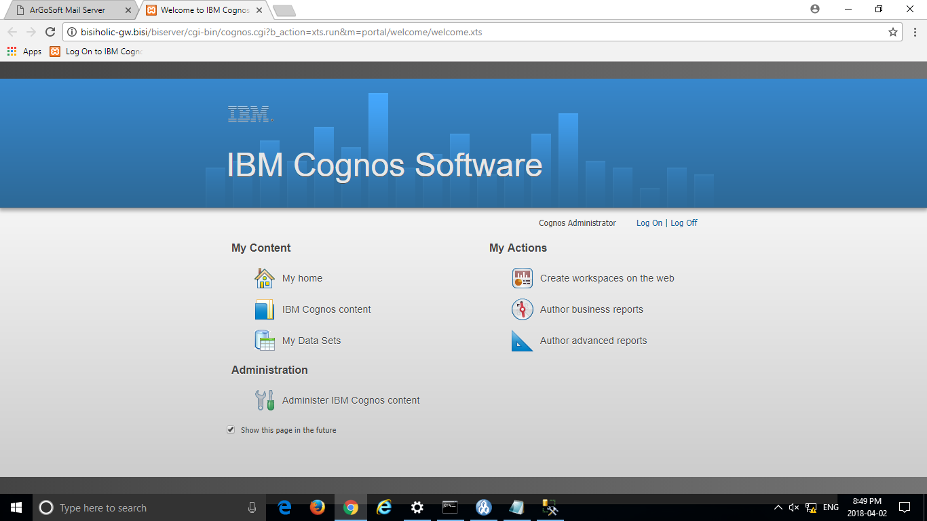

## Packages installed Access to GO Sales and GO Data Warehouse packages –

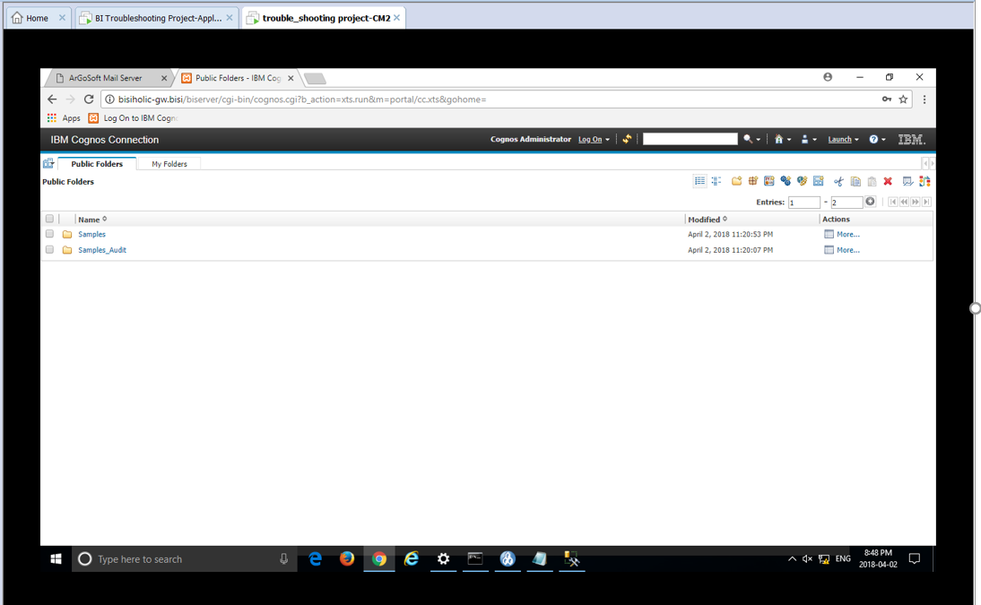

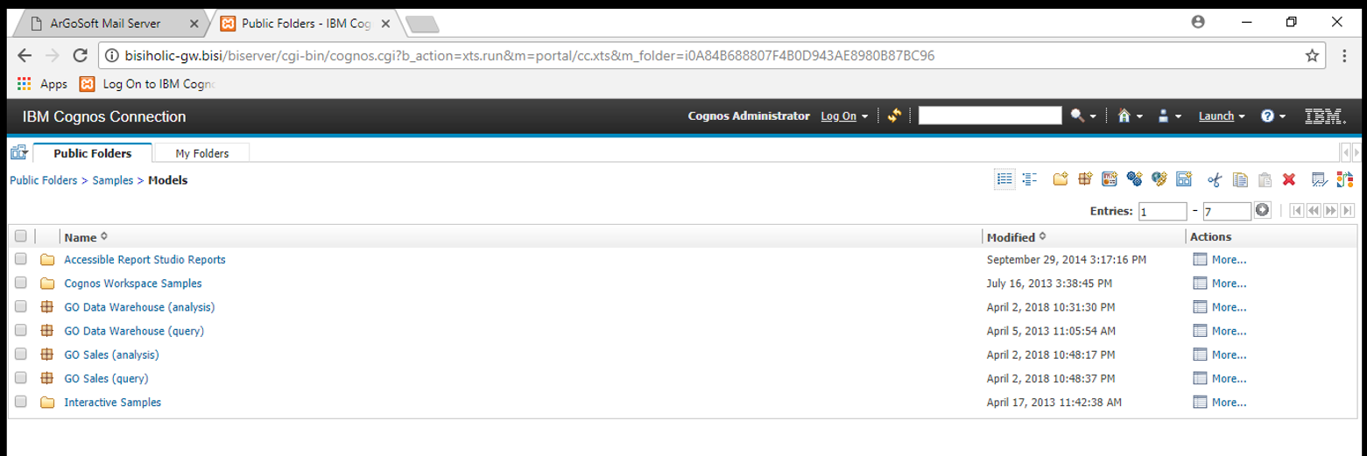

## Dispatcher URI for Gateway

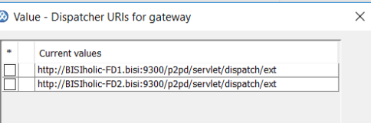

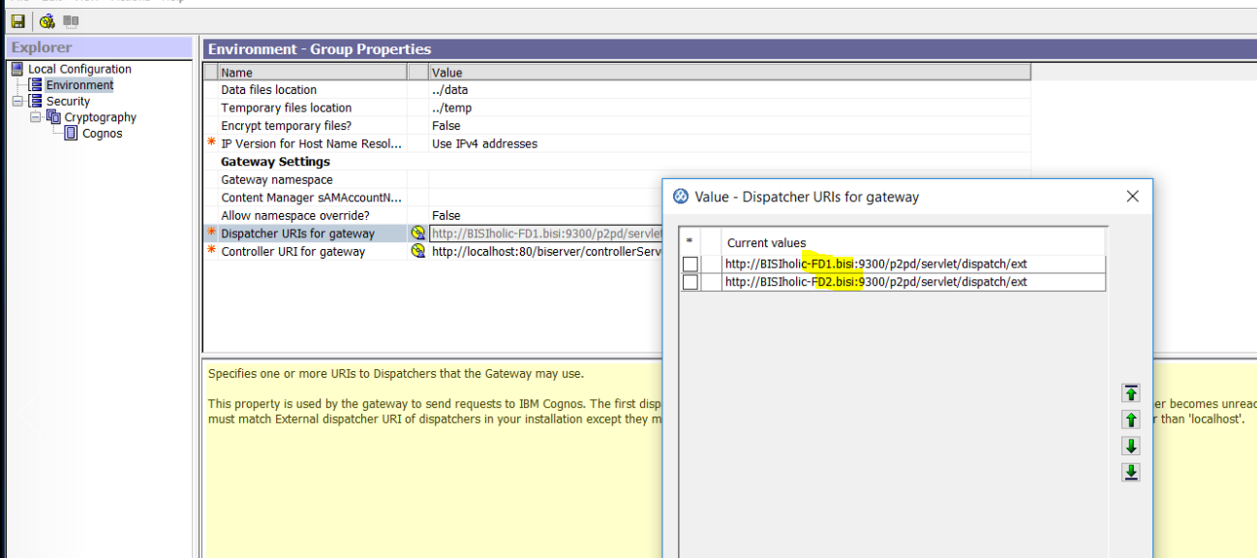

## P2plbDiag Screen capture ( File is provided with Submission)

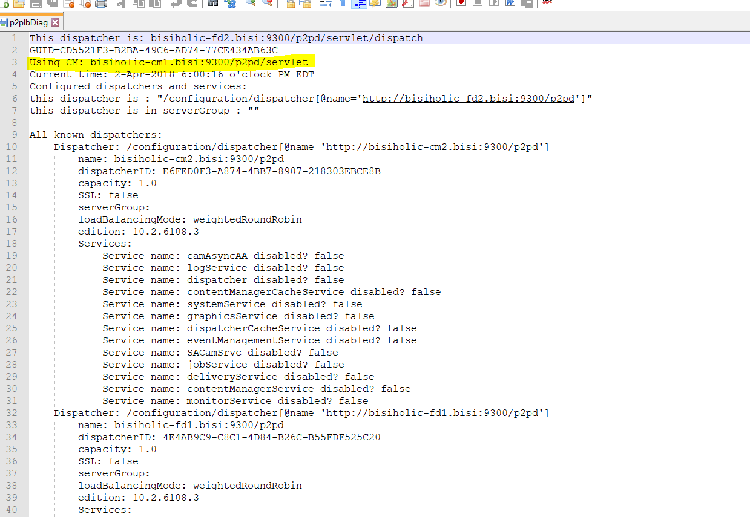

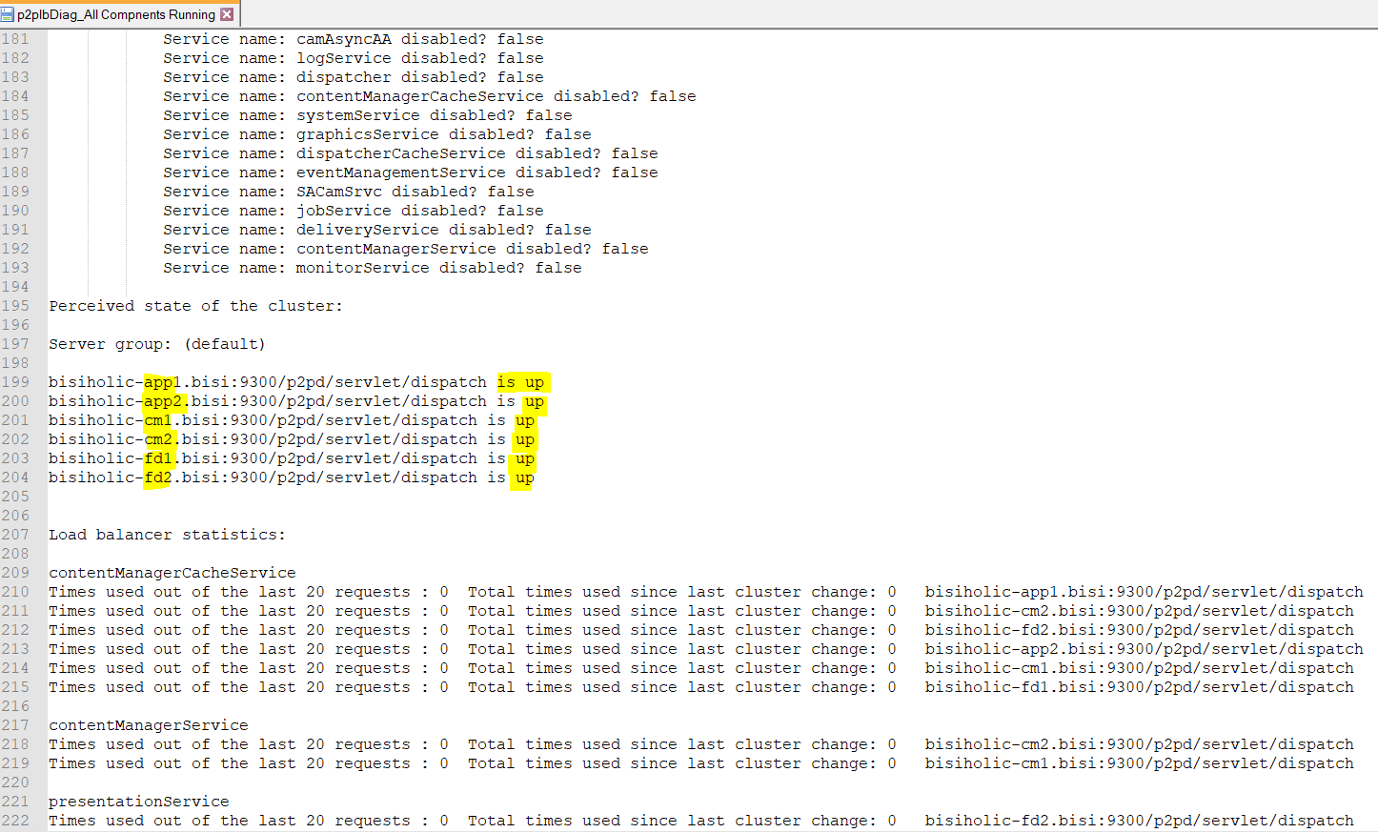

## All Dispatchers are active from portal

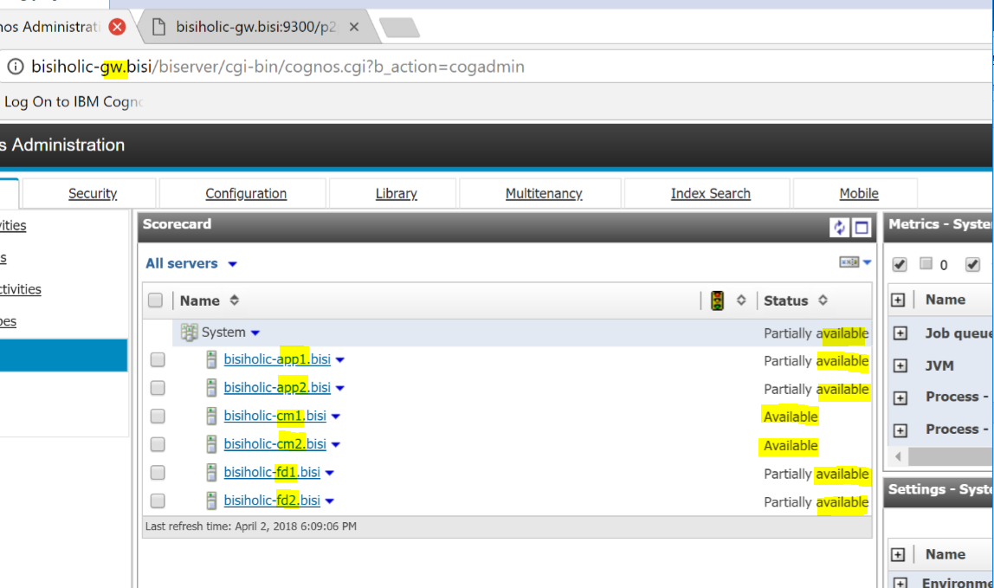

# Firewall Rules

## Inbound firewall rules

**Tcp inbound 1433,9362,9300,9400,9462,25,80,433**

**UDP inbound 1433,9362,93009400,9462,25,80,433**

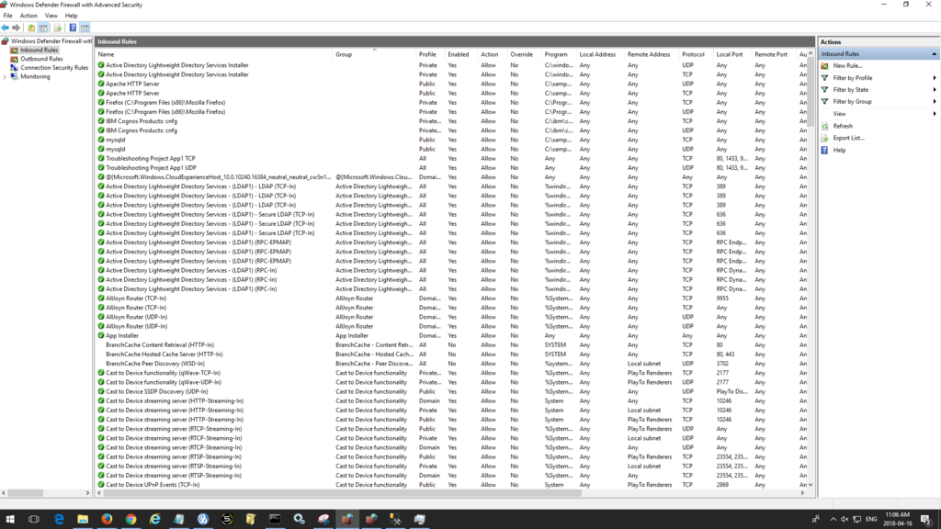

## Outbound firewall rules

**Tcp outbound 1433,9362,9300,9400,9462,25,80,433**

**UDP outbound 1433,9362,93009400,9462,25,80,433**

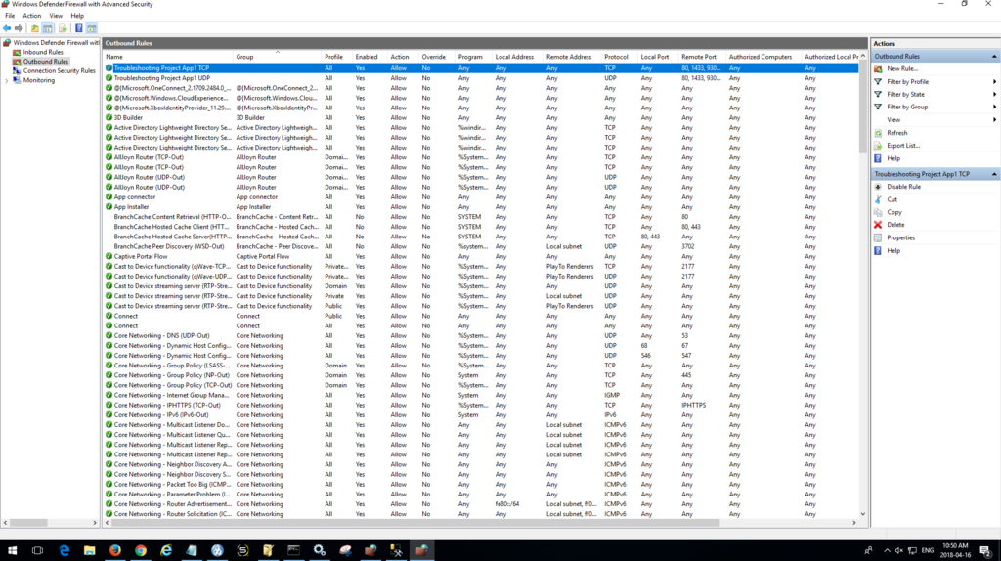

Reports Running successfully

## Report 1- 2011 Sales Summary “ From sales Package “

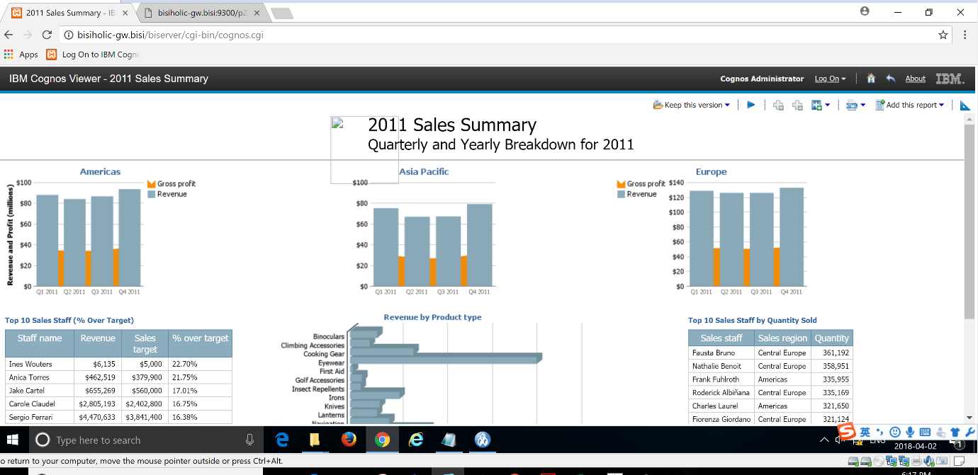

## Report 2- Budget_vs_Actual by Retailer “From DW Package “

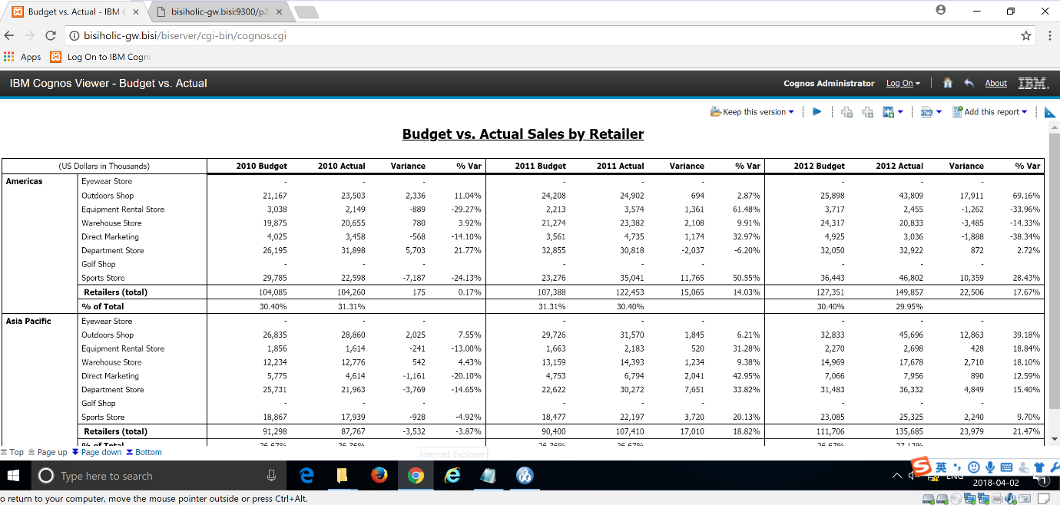

# ADLDS

### ADLDS Configuration in CM1

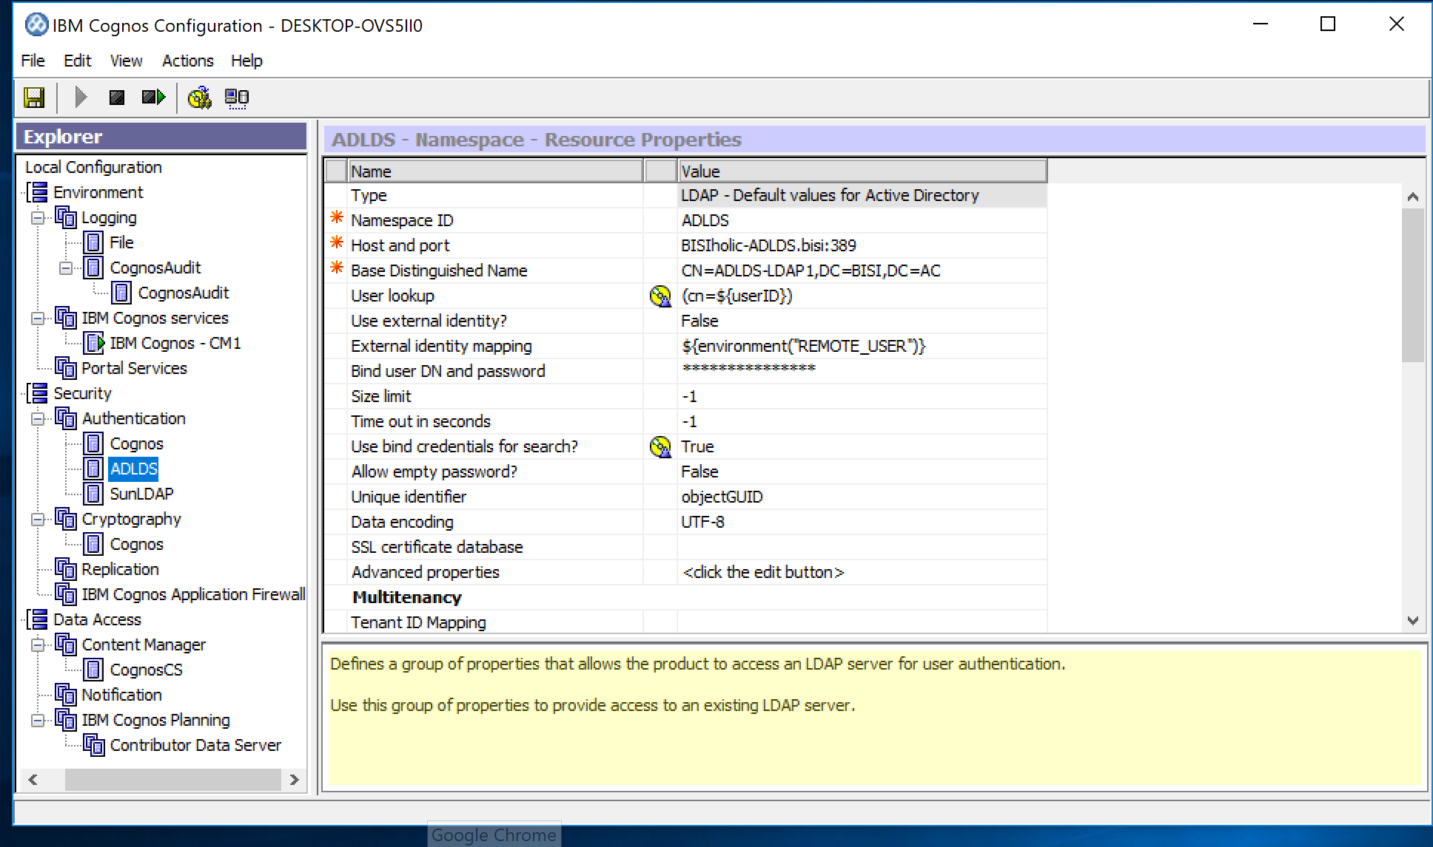

### ADLDS Configuration in CM2

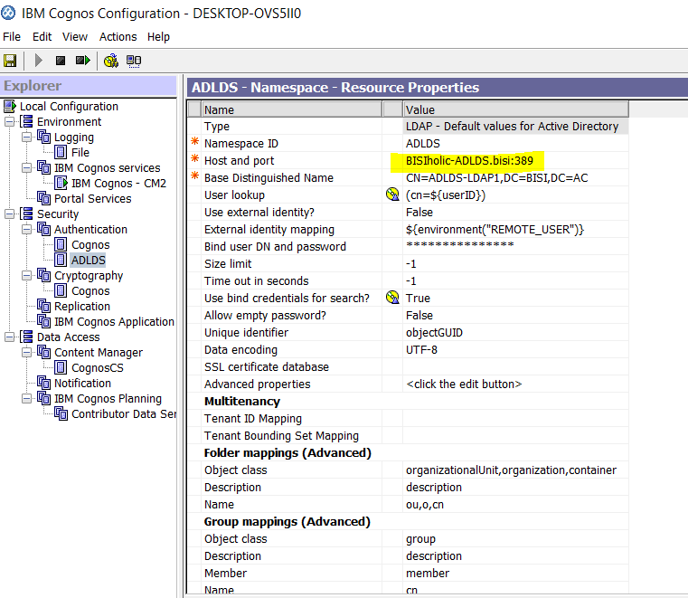

### ADLDS Directory

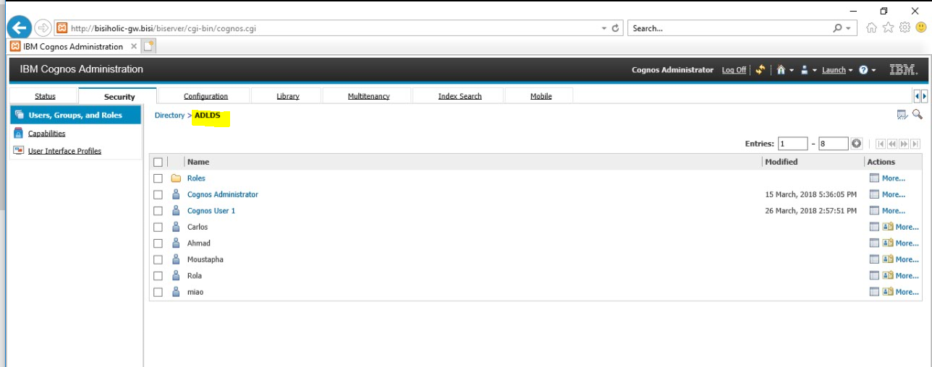

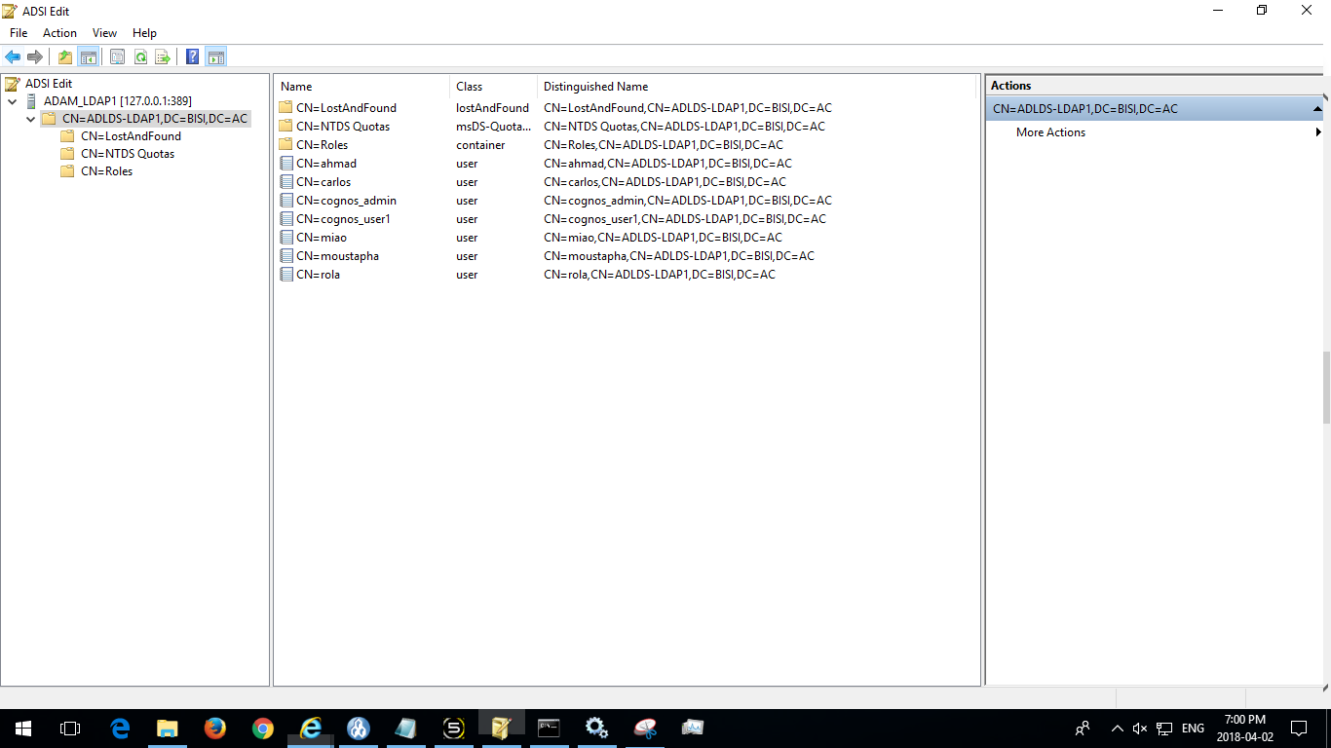

# Basic Security

## Allow Anonymous Access No

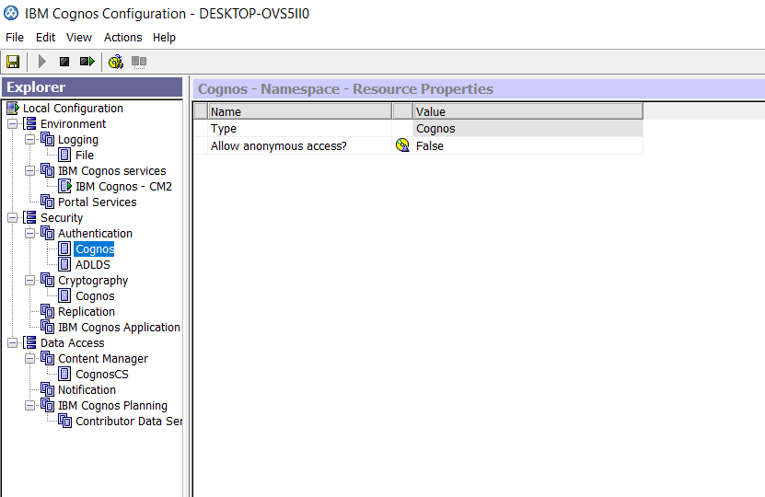

## Restrict Access to members of the built-in namespace

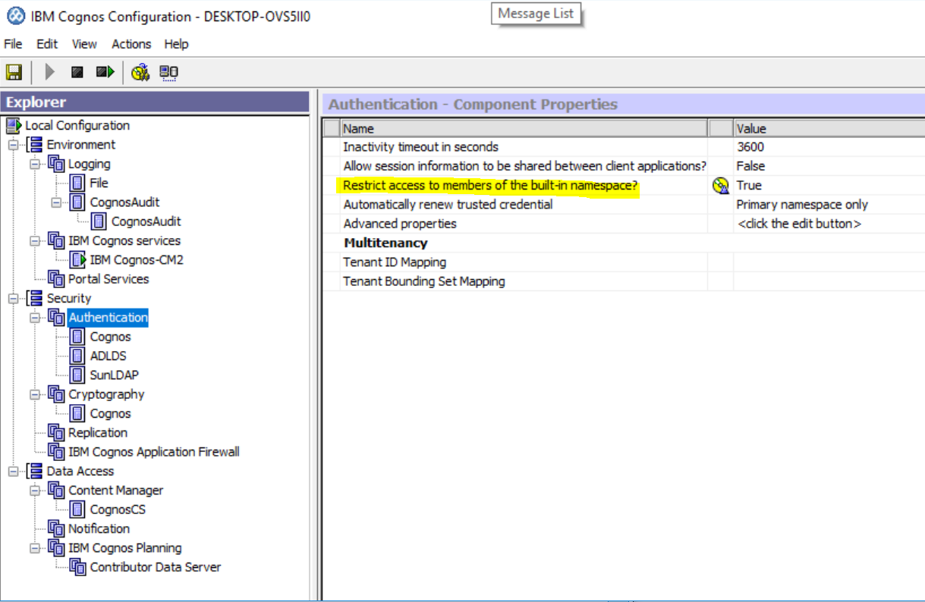

## Unauthorized user ( Cognos User1 – Not allowed to login)

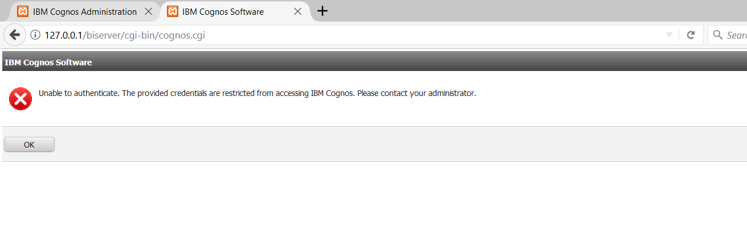

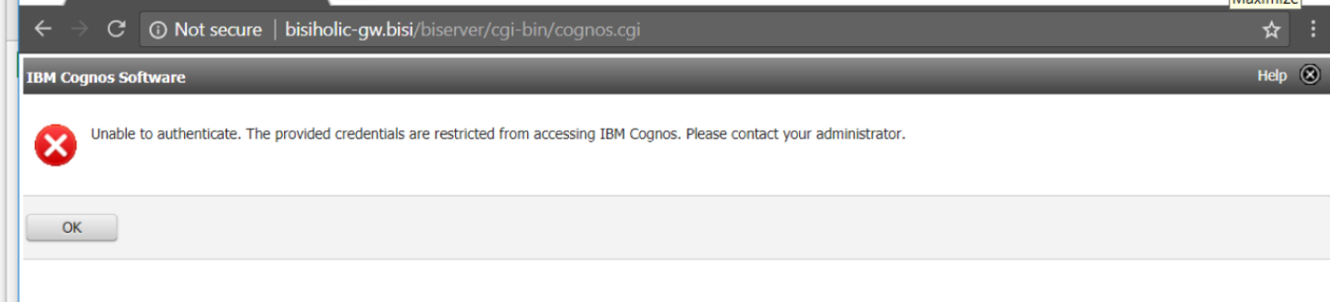

# Third Party Components

## SunLDAP Connection

### Log IN Screen

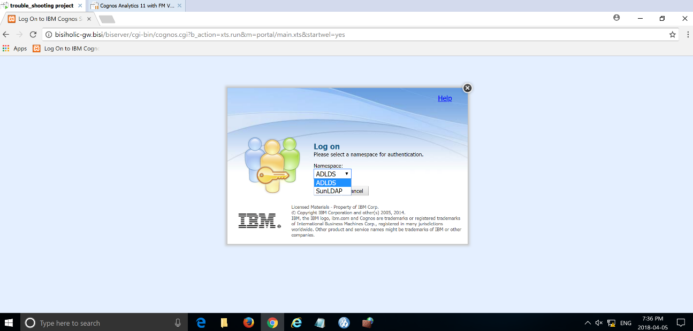

### Sun-LDAP Configuration in CM1

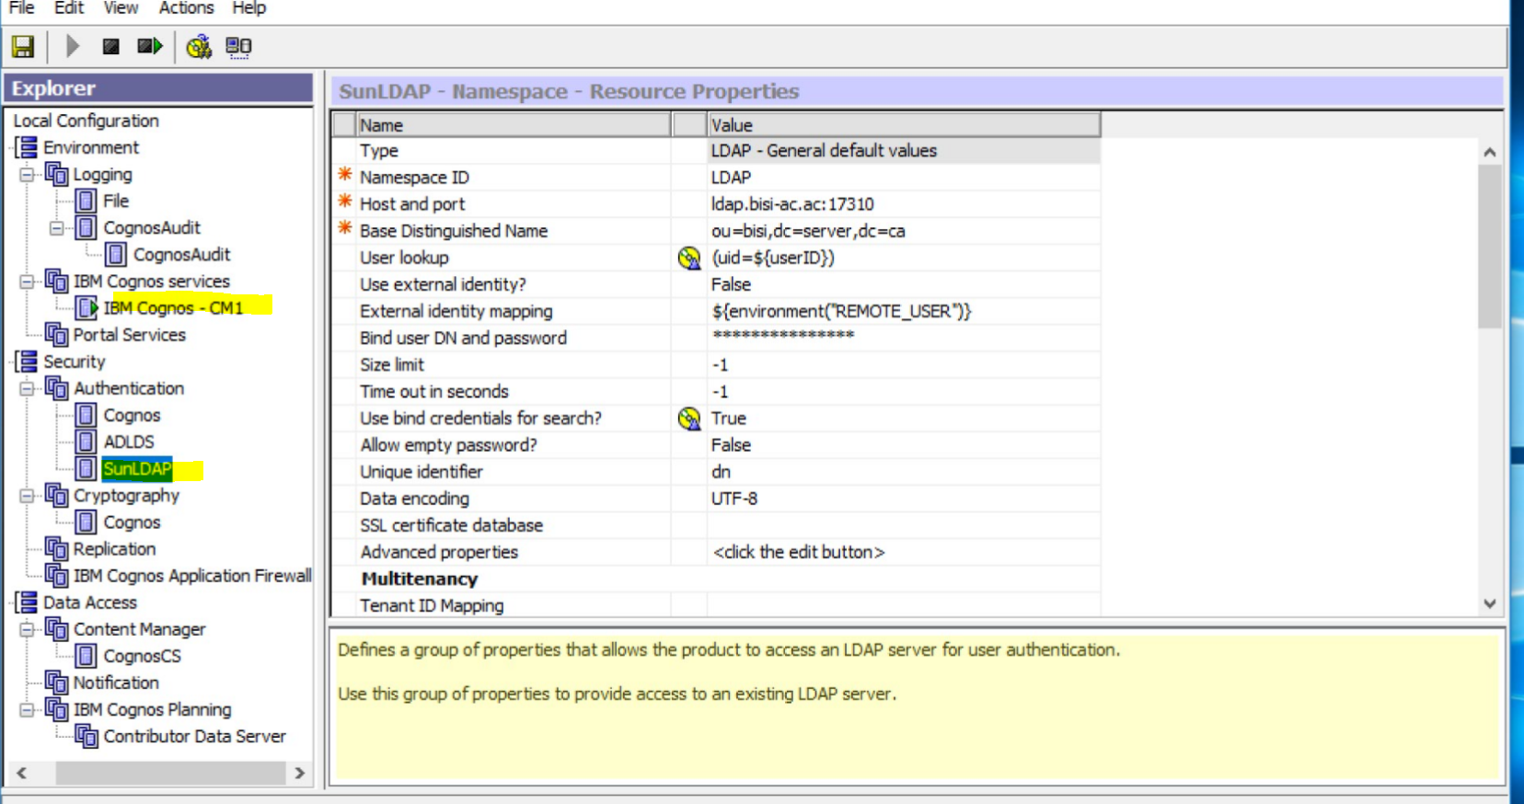

### Sun-LDAP Configuration in CM2-

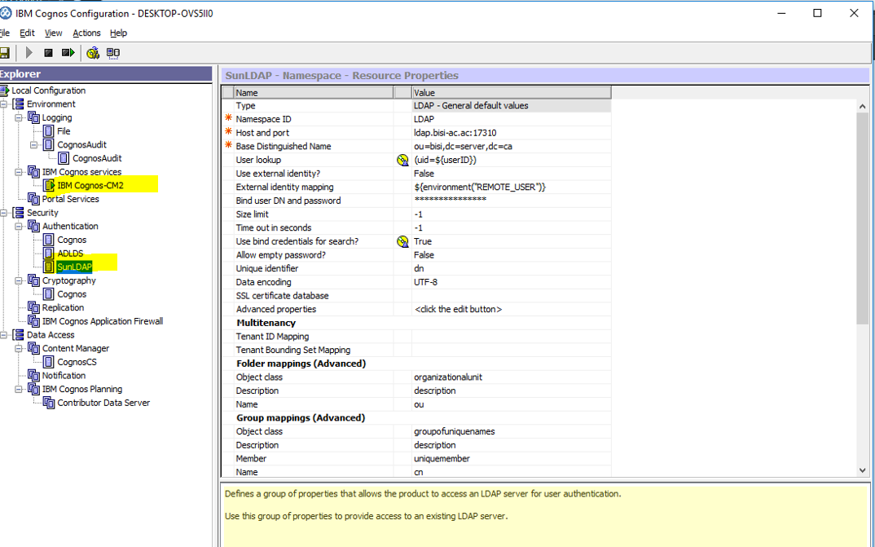

### Users in Sun-LDAP

#### Ahmad, Carlos added

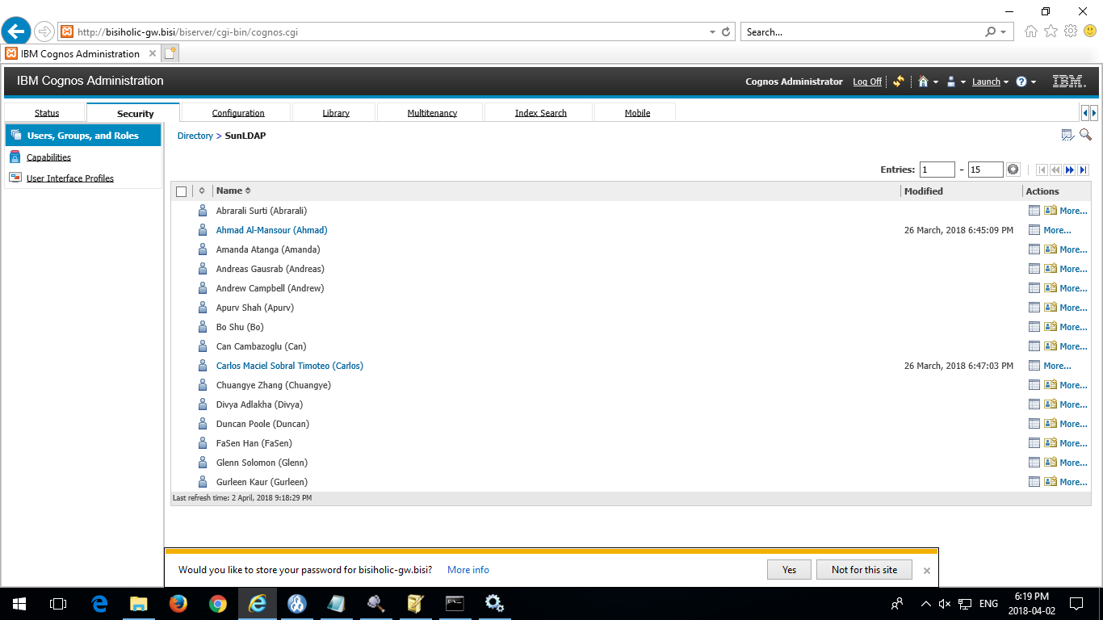

#### Mia, Rola, Moustapha

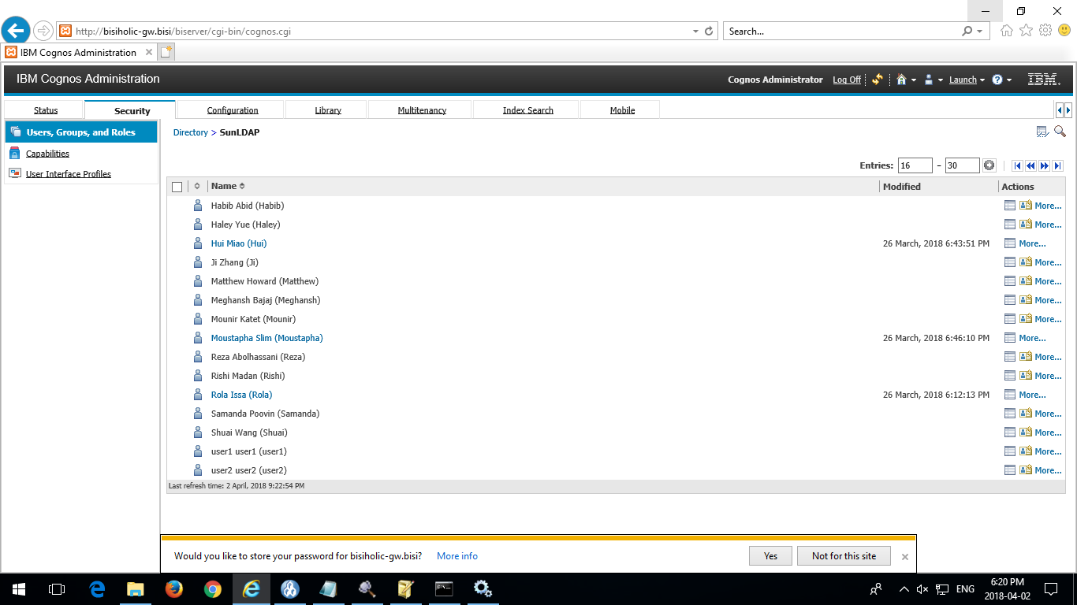

## Audit DB Connection

### Audit DB in MSSQL

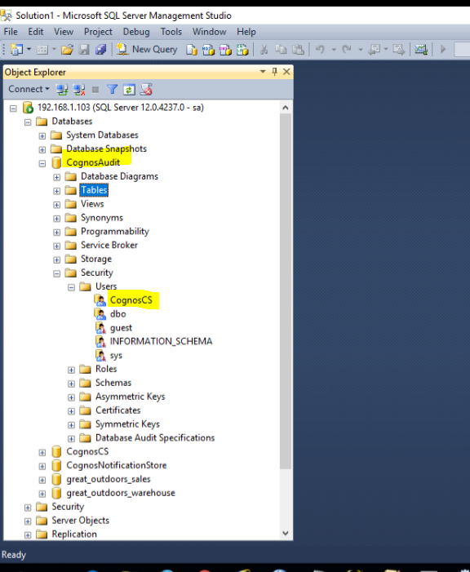

### Audit DB Configuration in CM1

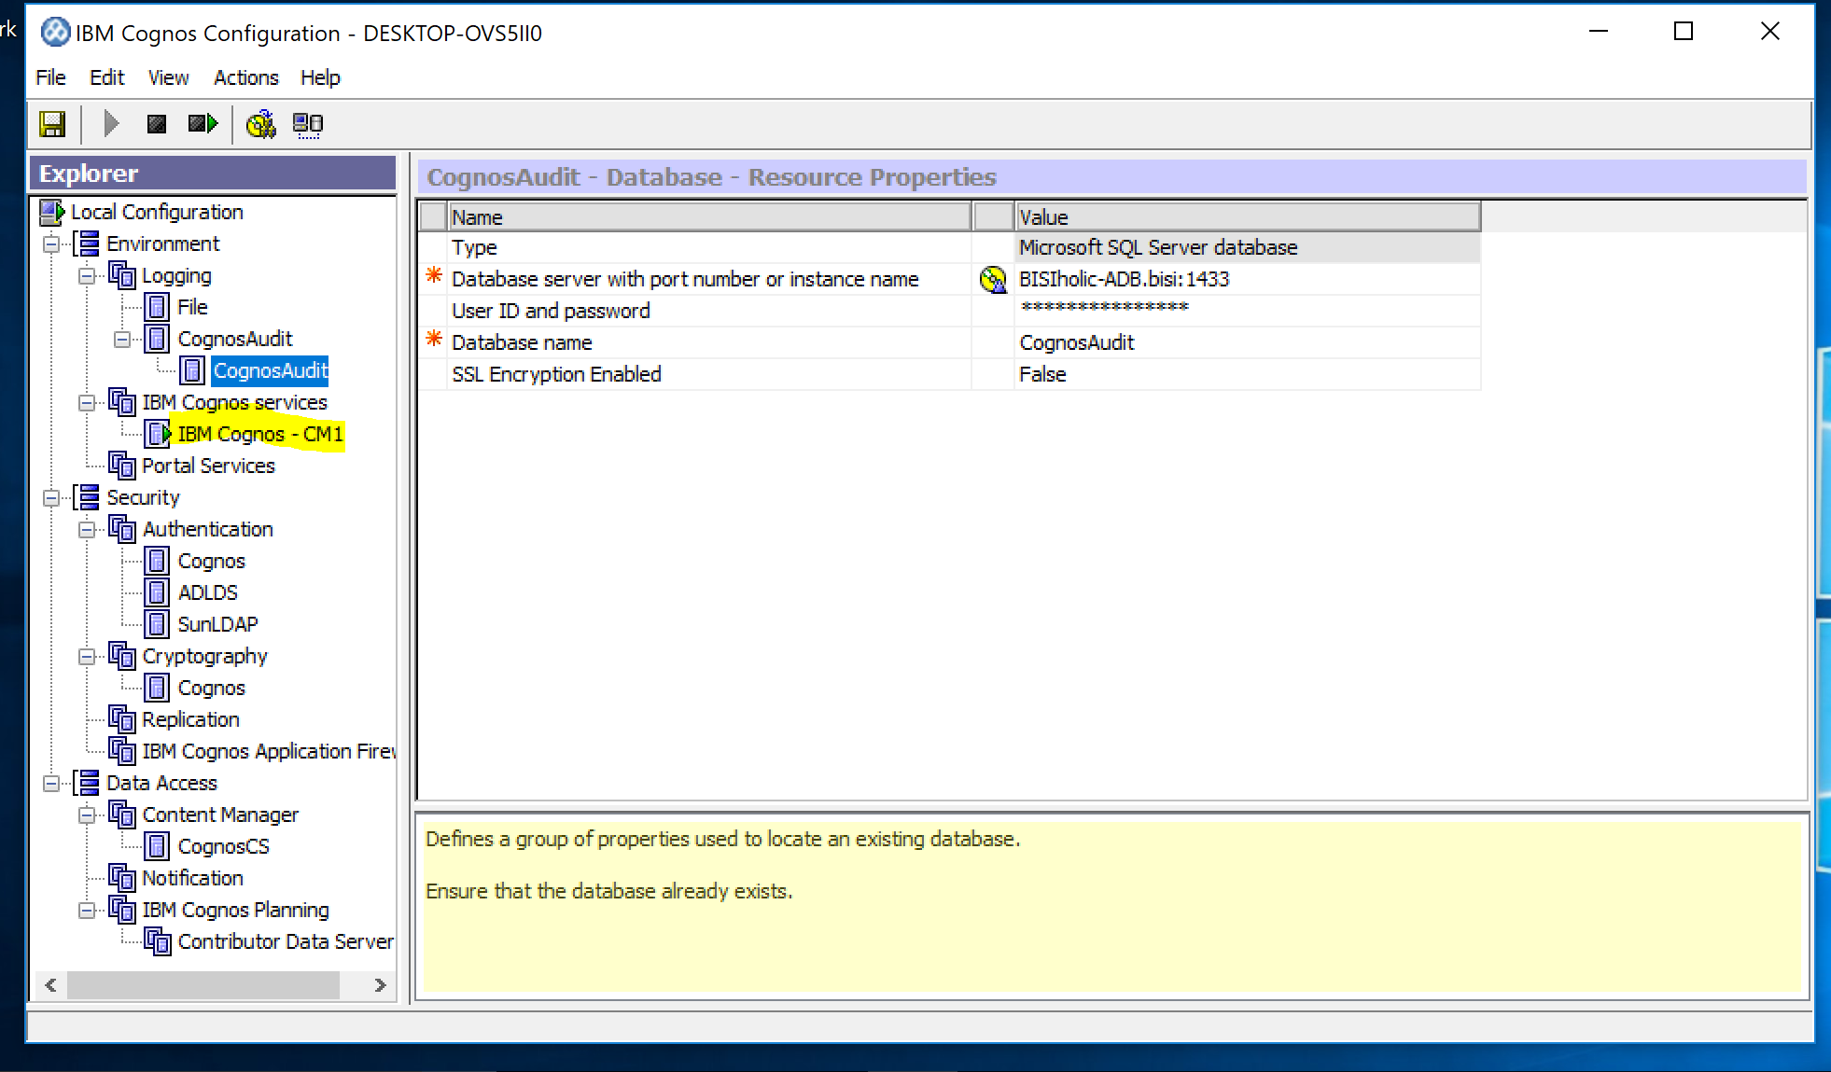

### Audit Configuration in CM2

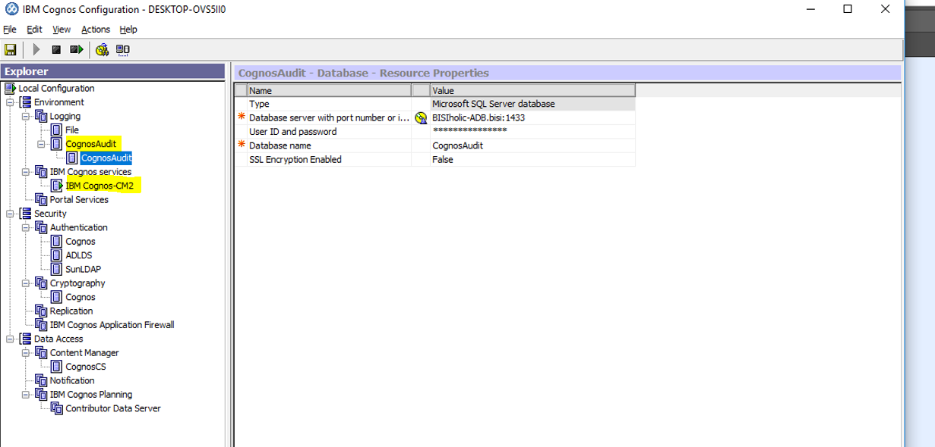

### Audit DB Configuration in App1

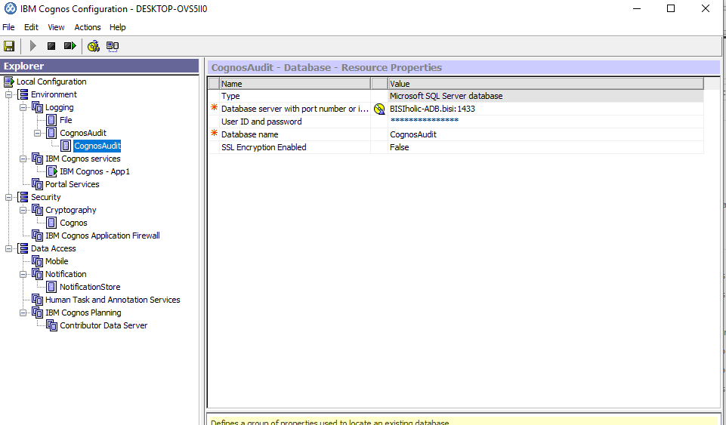

### Dispatcher Logging to **basic**

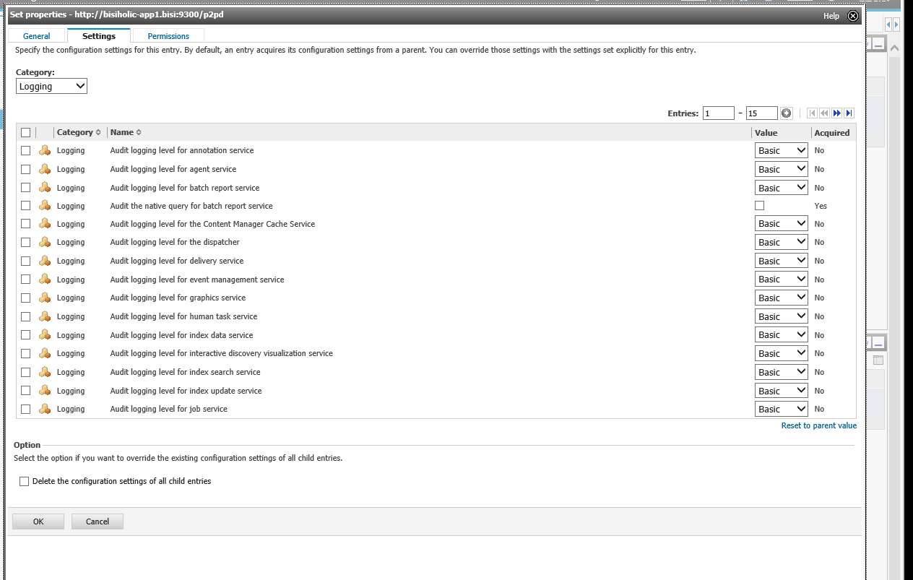

### Audit Package installed

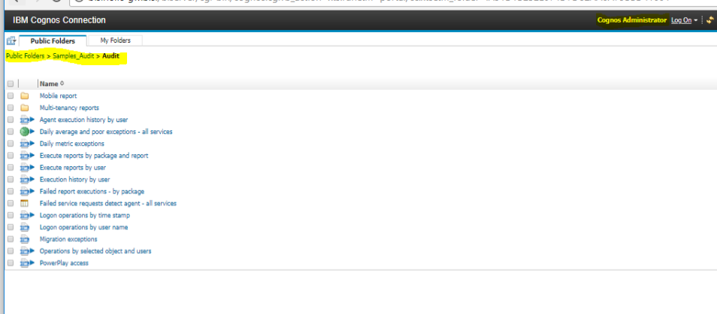

### Running a report from the Audit Sample (Logon operations by User Name)

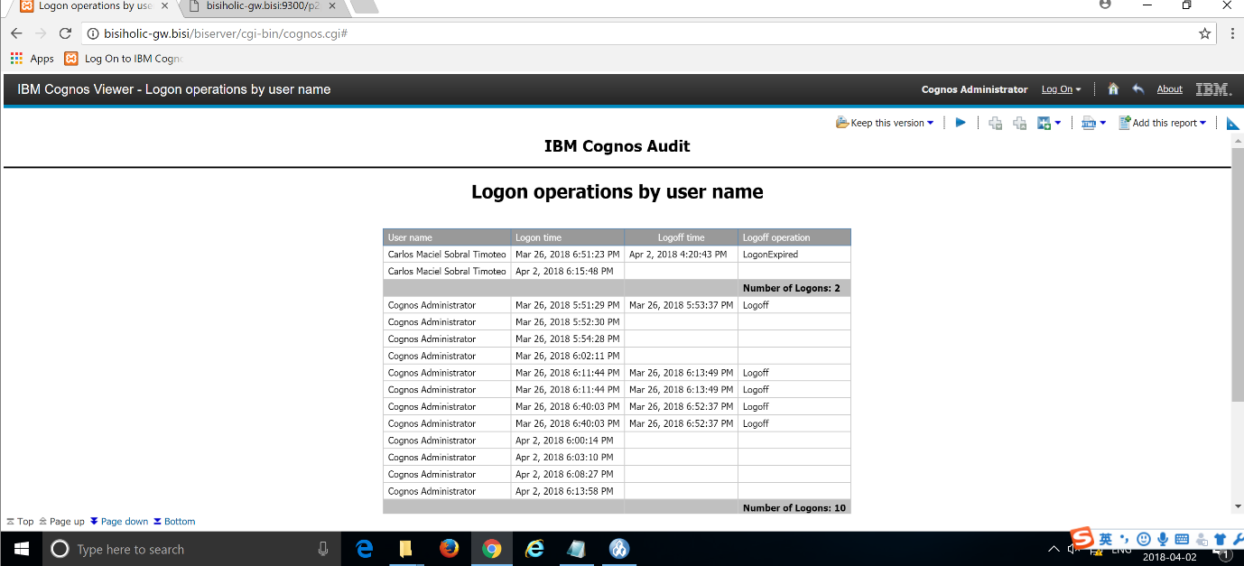

## SMTP

### Notification Configuration in App1

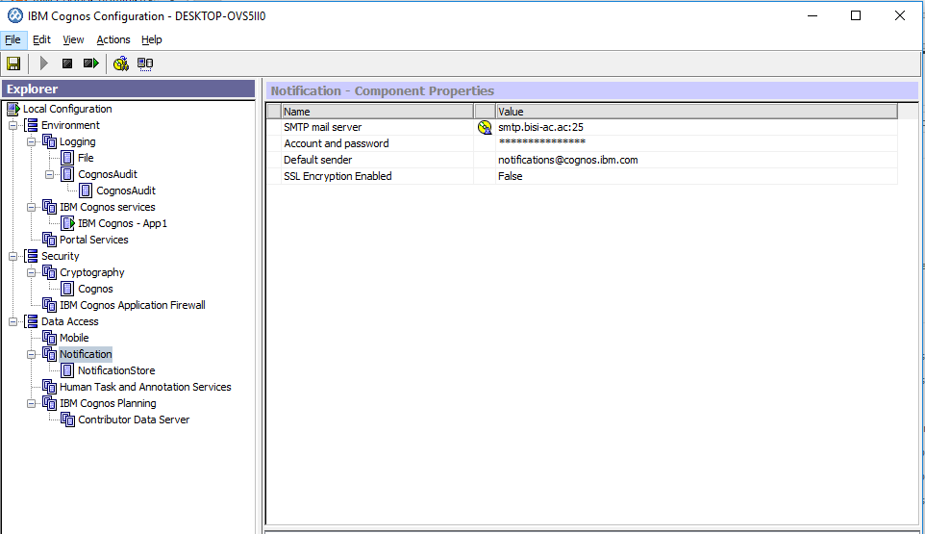

### Notification Configuration in App2

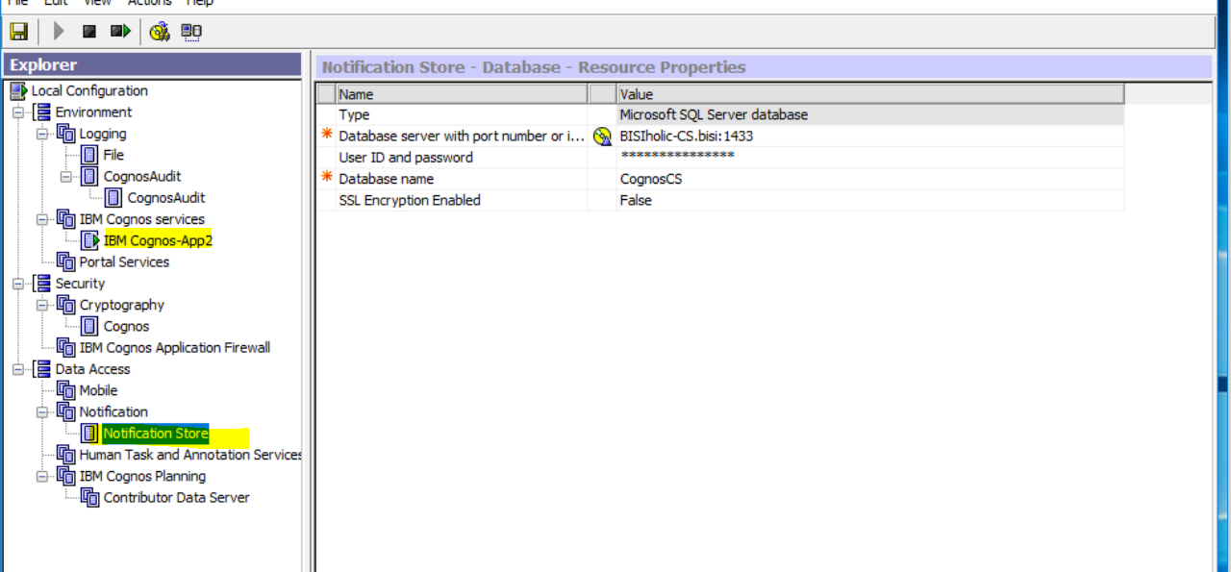

### Notification Configuration in CM1

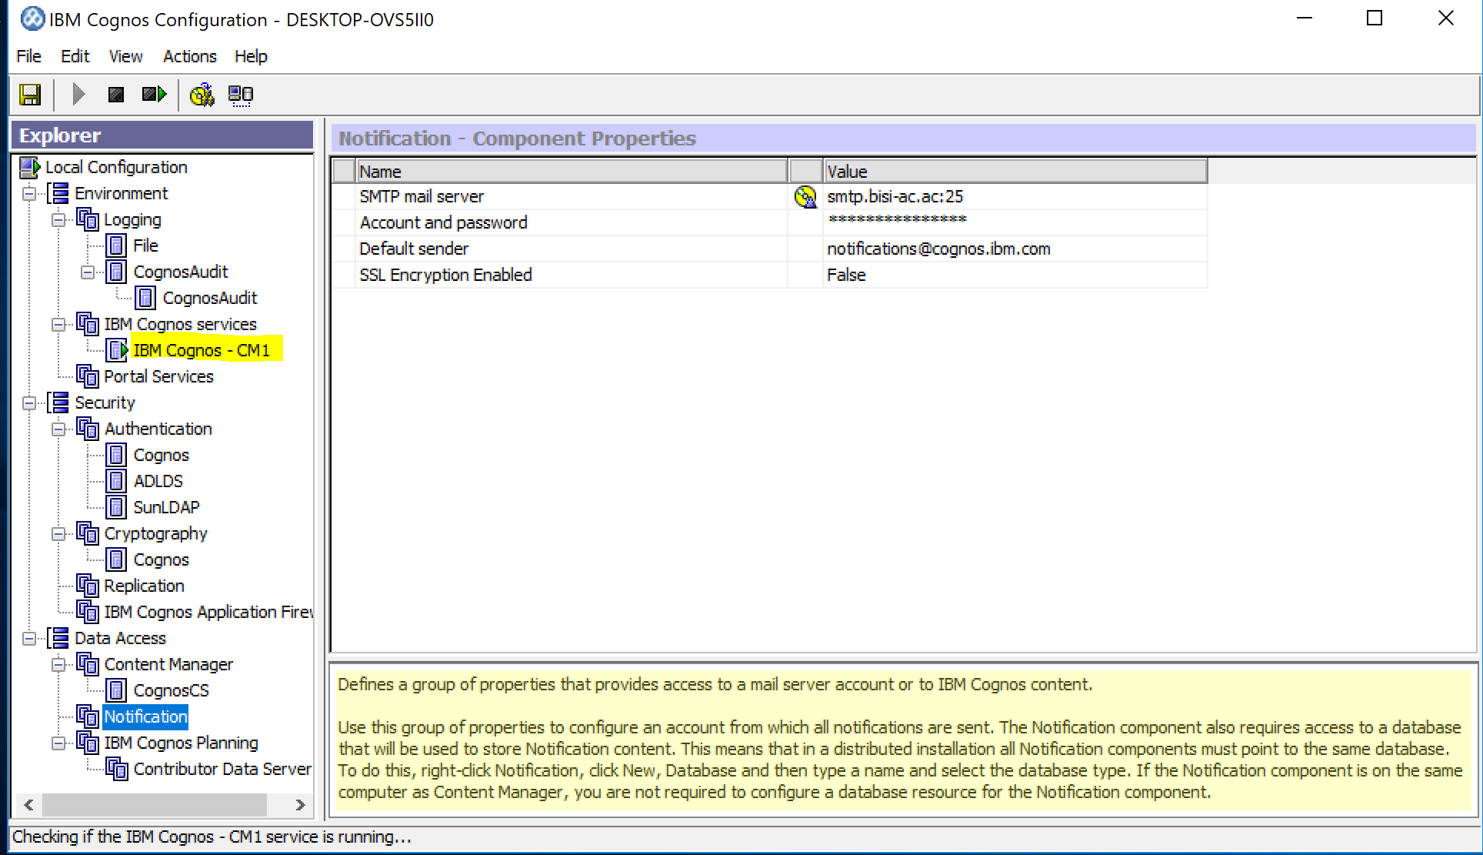

### Notification Configuration in CM2

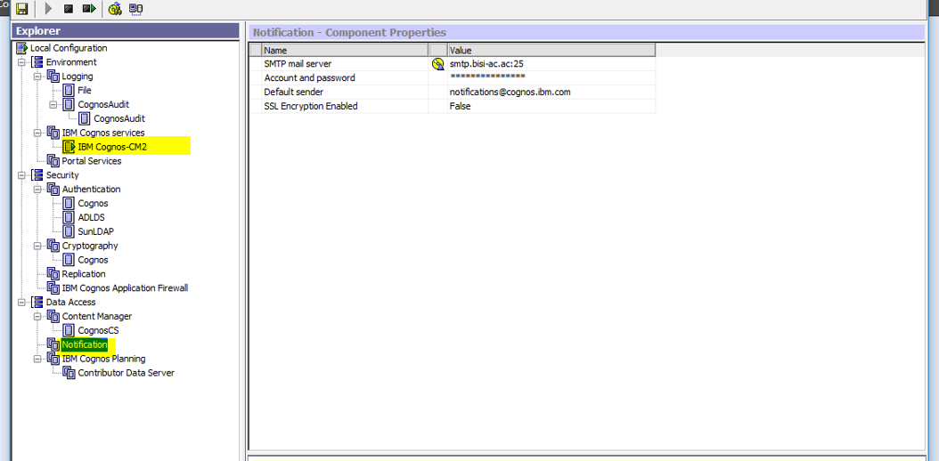

### **Mail for evidence:**

### Sending an email

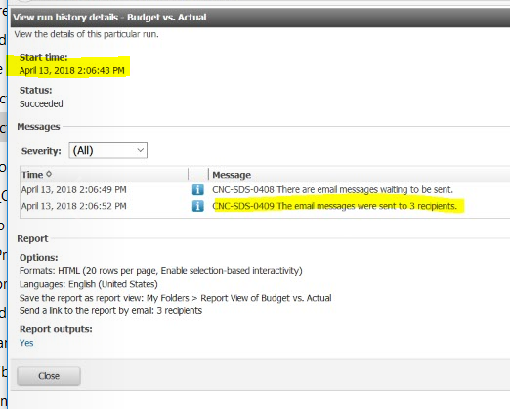

Email Sent Successfully Carlos VM-Email Message Received sent from Ahmad user ( LDAP)

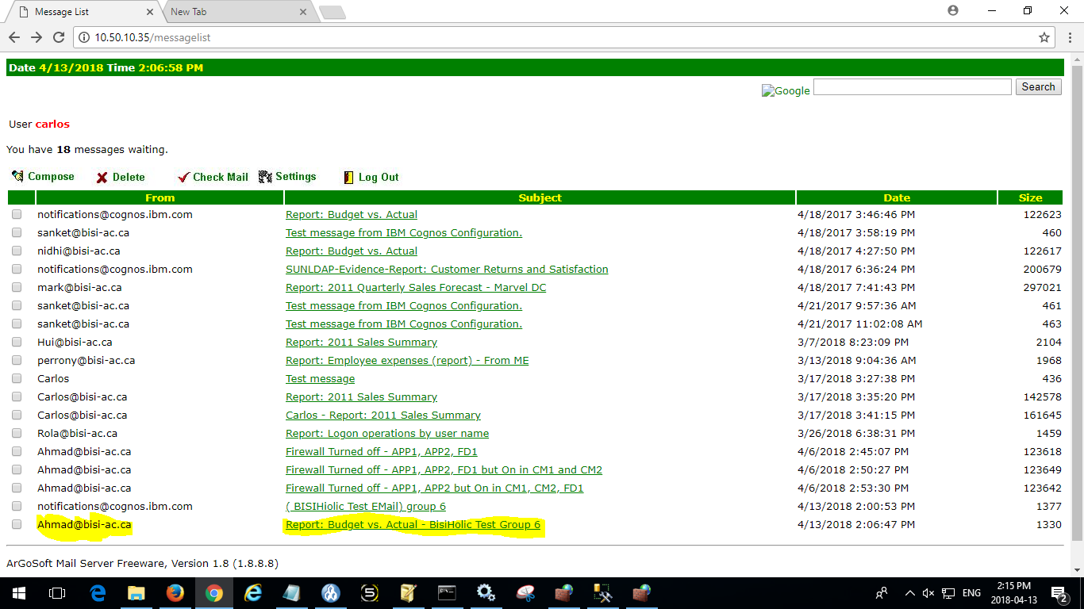App1 & App2 Tunning : Properly tuned components (basic tuning – Processing capacity, # of report processes)

APP1- tuning 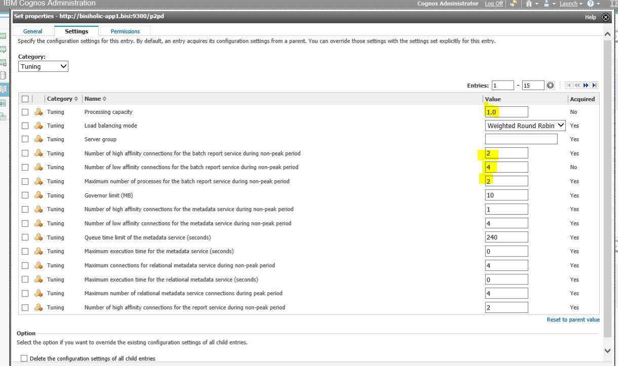

APP2- tuning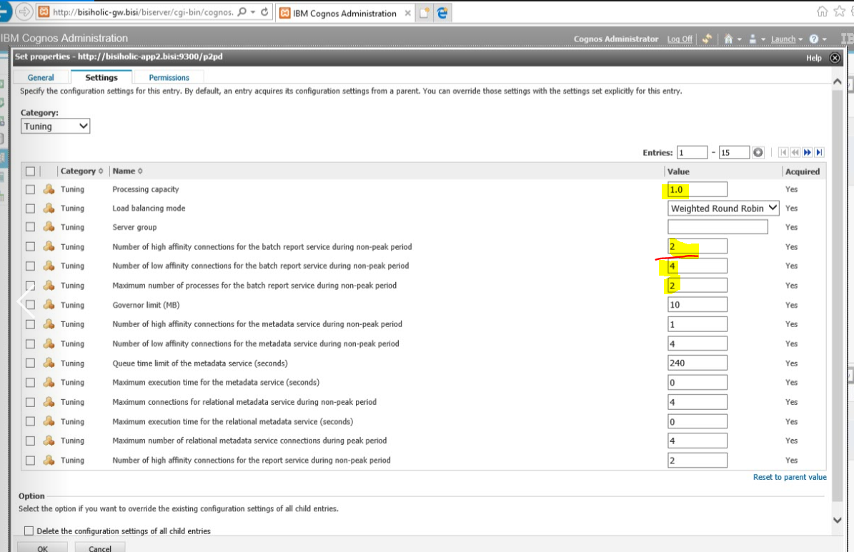

# Load balancing: Application Server

Load balancing must occur when both app servers are available.

After Running multiple Reports -

### App1- performance metrics

Report Service – App1 Number of Successful Requests

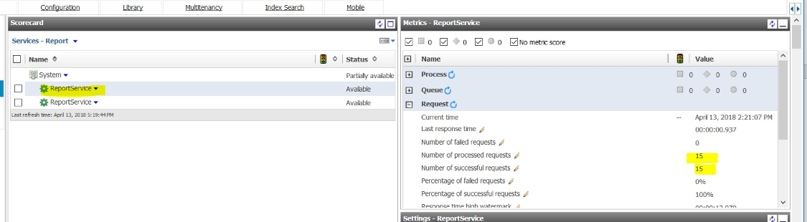

Batch Report Service – App1 Number of Successful Requests

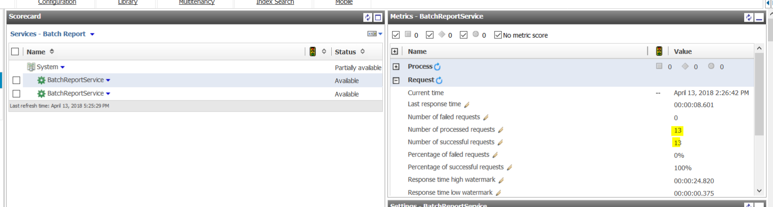

Past Activities – App1 – Emails sent through App1

Reports can be emails regardless of application server the report is being run from.

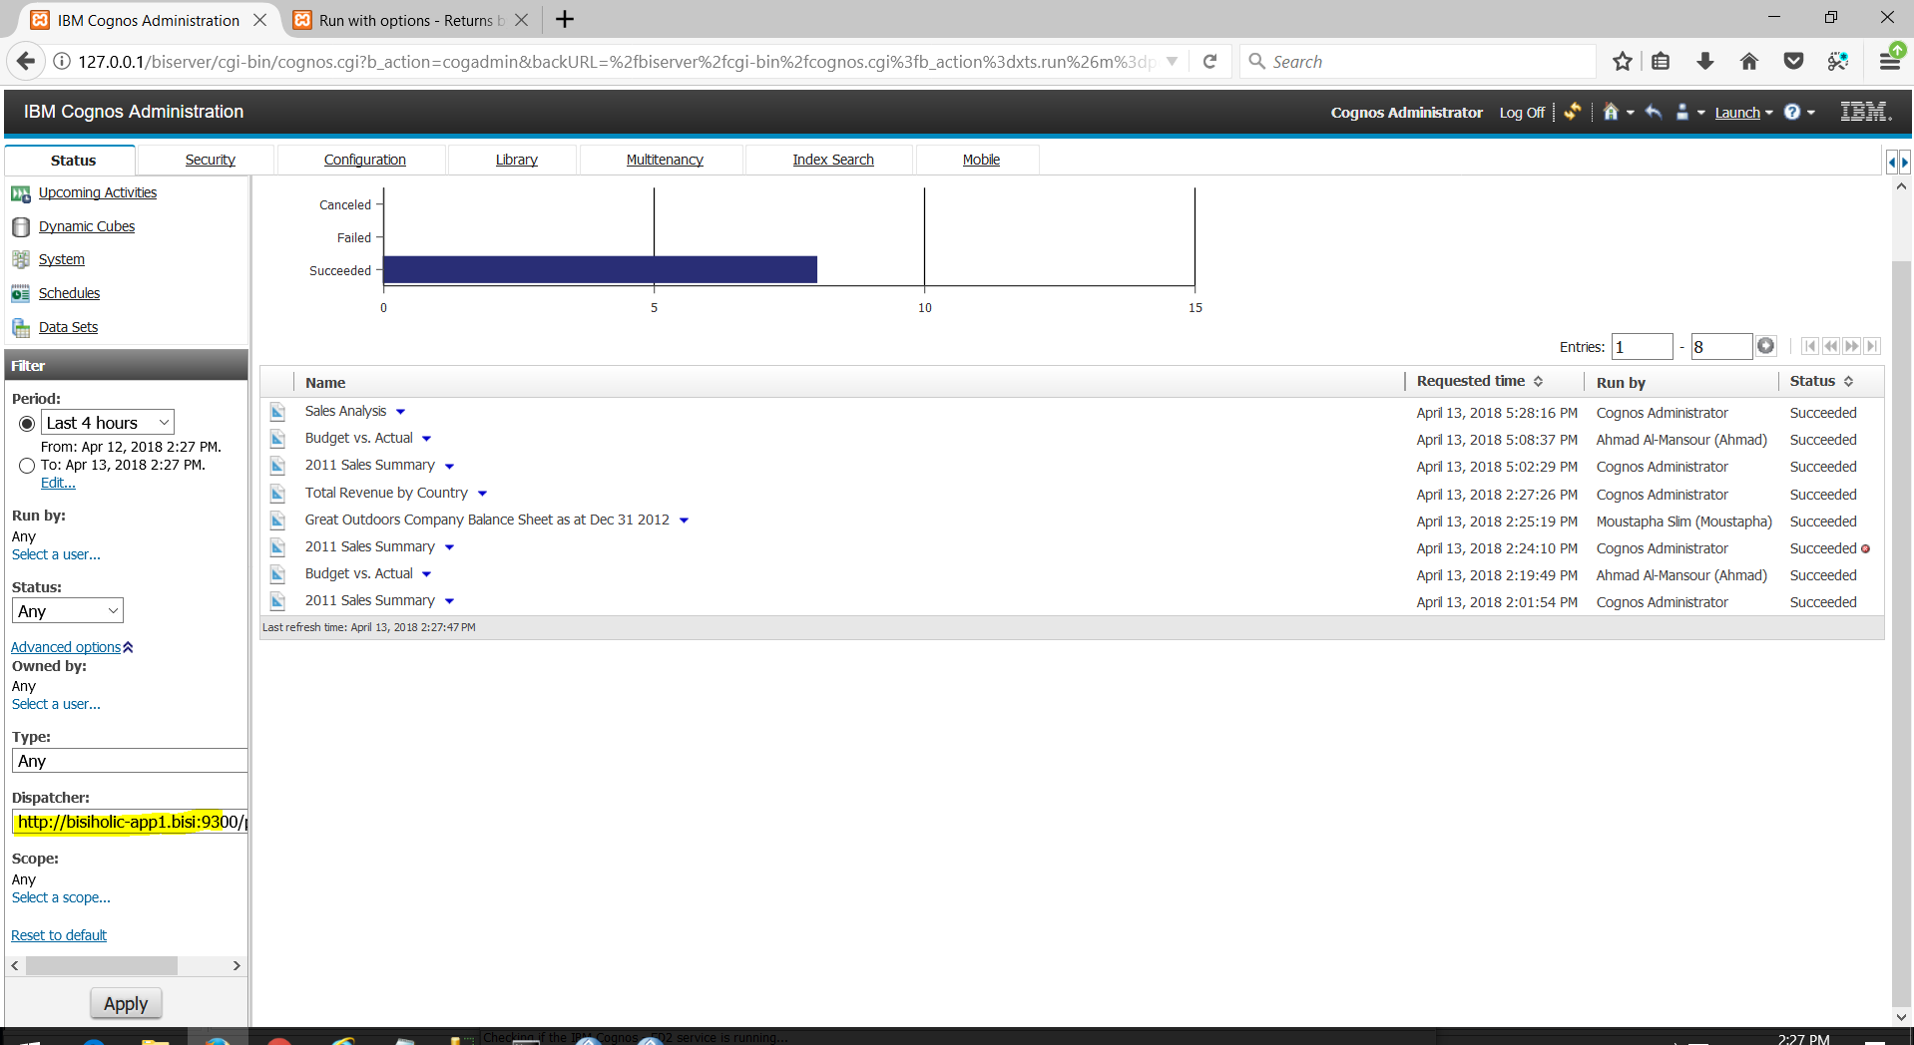

### App2- performance metrics

Report Service – App2 Number of Successful Requests

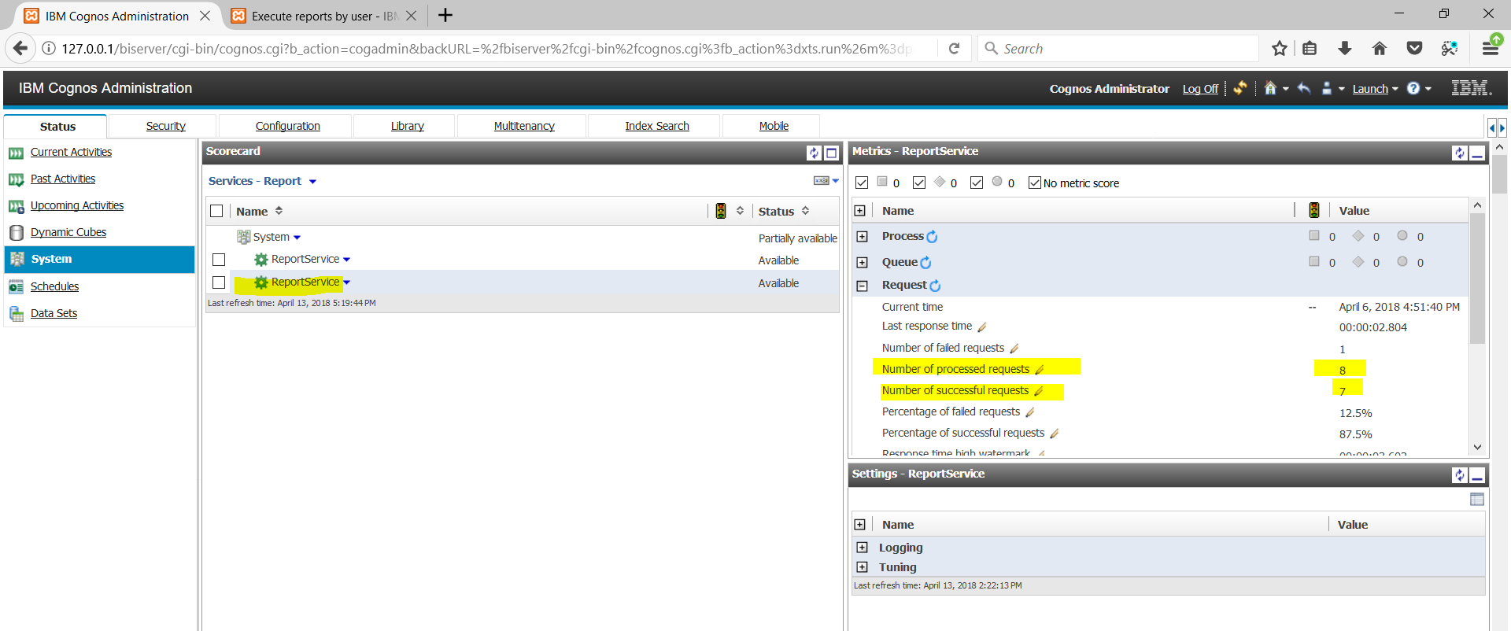

Batch Report Service – App2 Number of Successful Requests

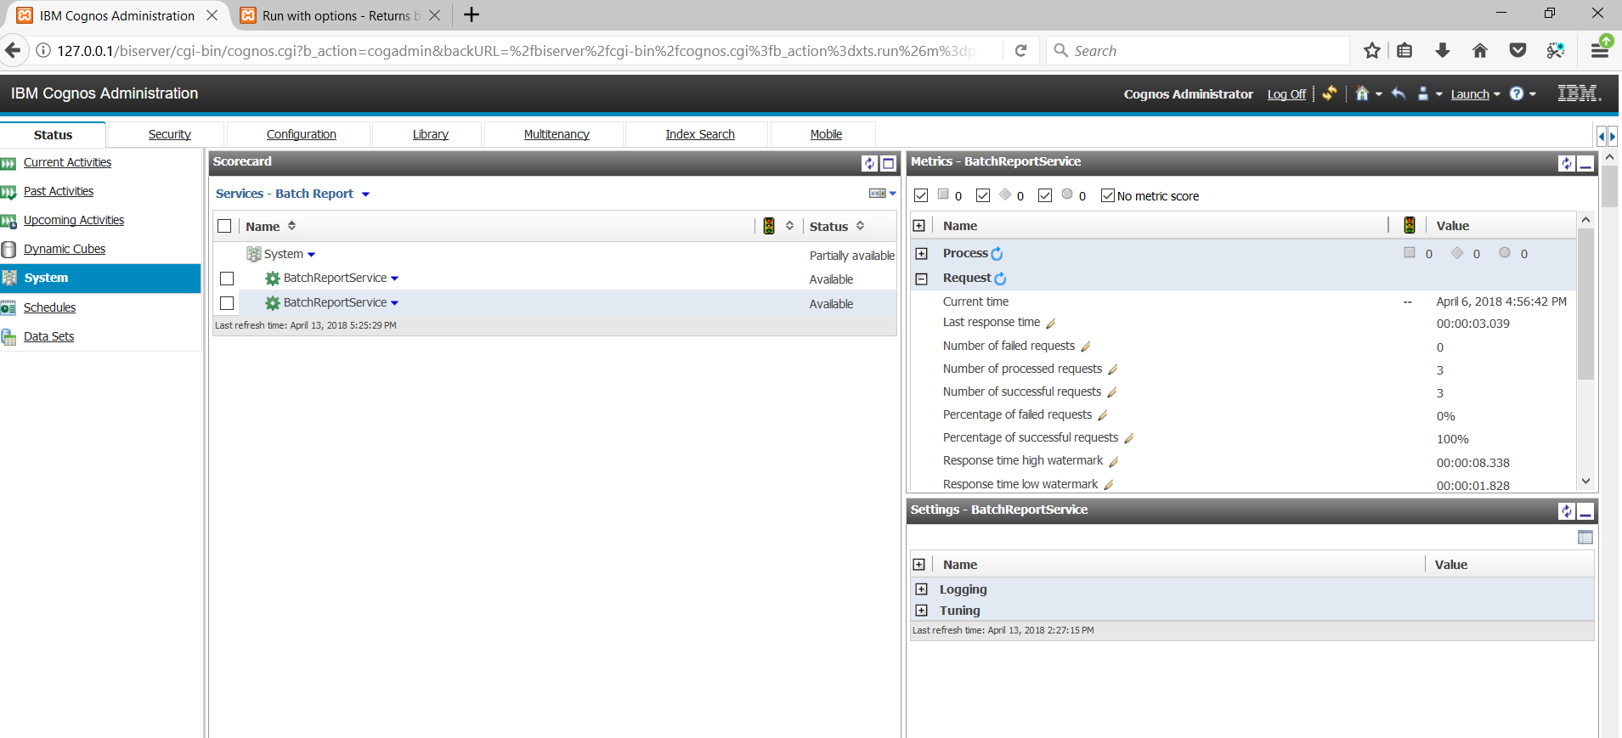

Past Activities – App2 – Emails sent through App2

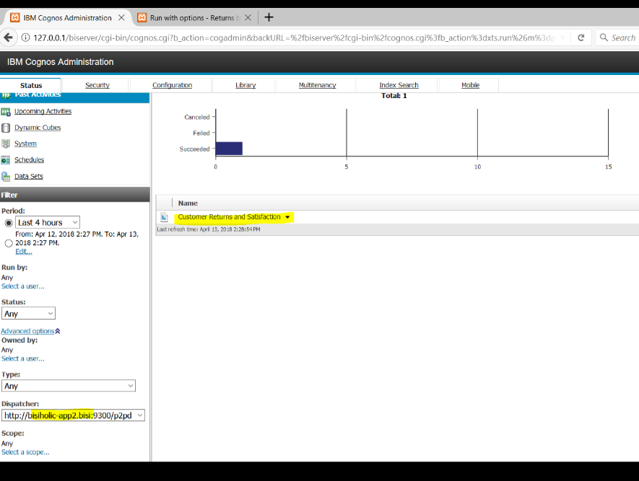

# Content Security

## Cognos Administration

### Great_outdoors_warehouse - Permissions

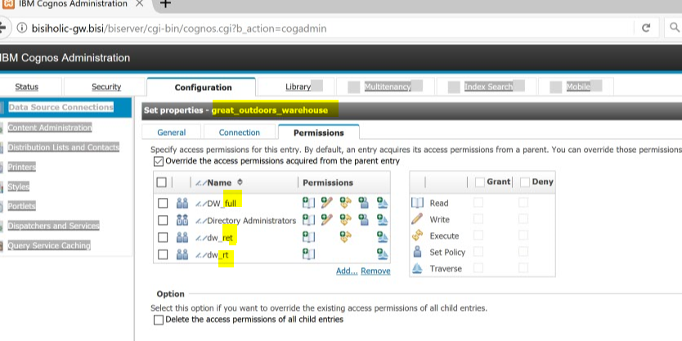

### GoData Warehouse Group

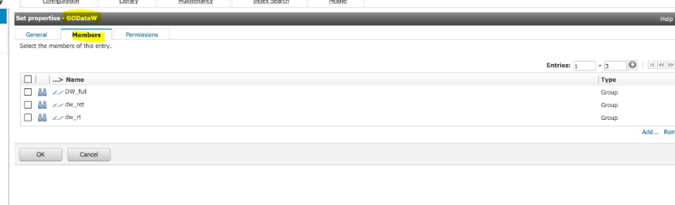

### GoDW-Admin – members

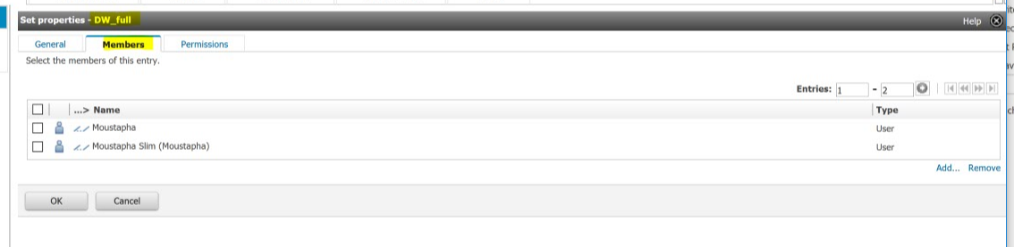

### GoDW- Read – members

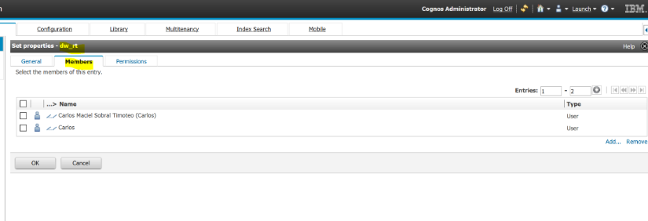

### GoDW- Read Execute – members

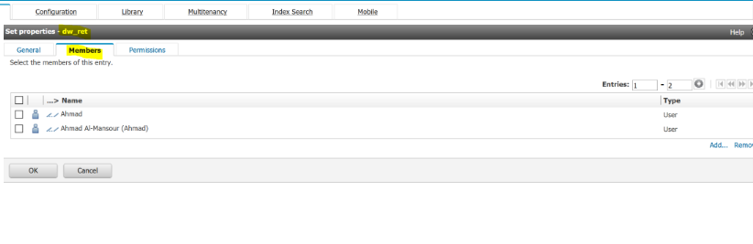

### Great_outdoors_sales – permission

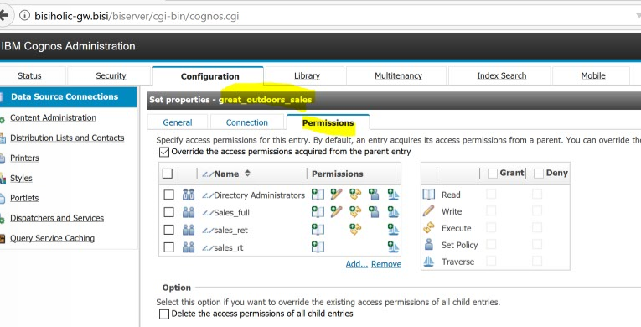

### GoSales-Admin – members

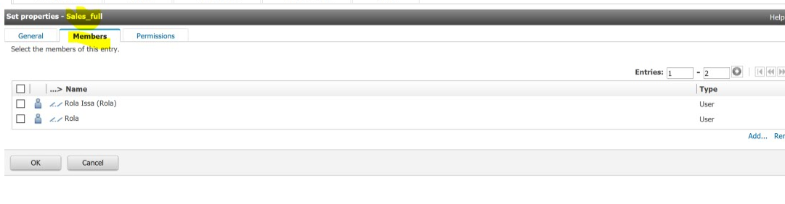

### GoSales - Read – members

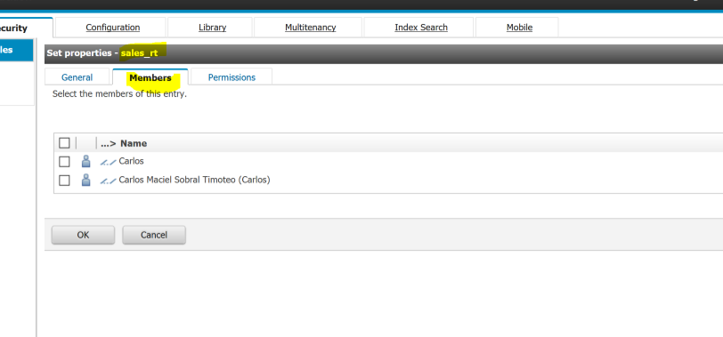

### GoSales - Read Execute – members

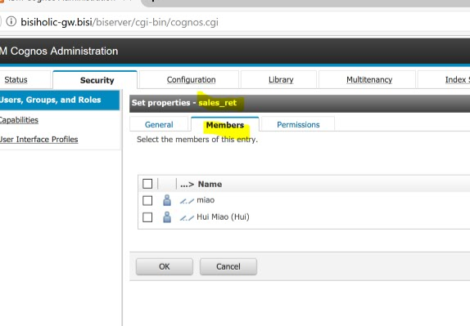

### GoSales - All users – traverse members

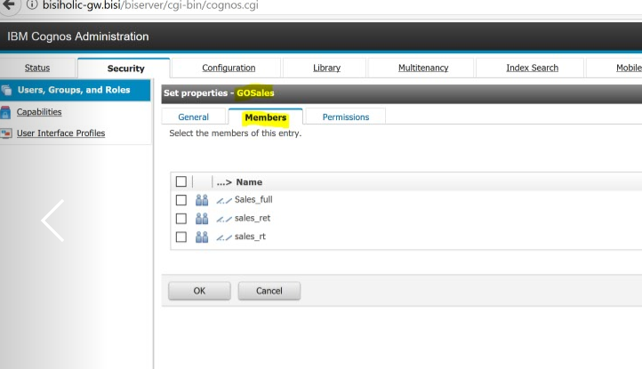

## Cognos Connection:

The GO Data Warehouse package is only accessible to users that belong to the GODataW group, where you will create users that have reader, consumer and administrator roles.

### Public Folder permissions

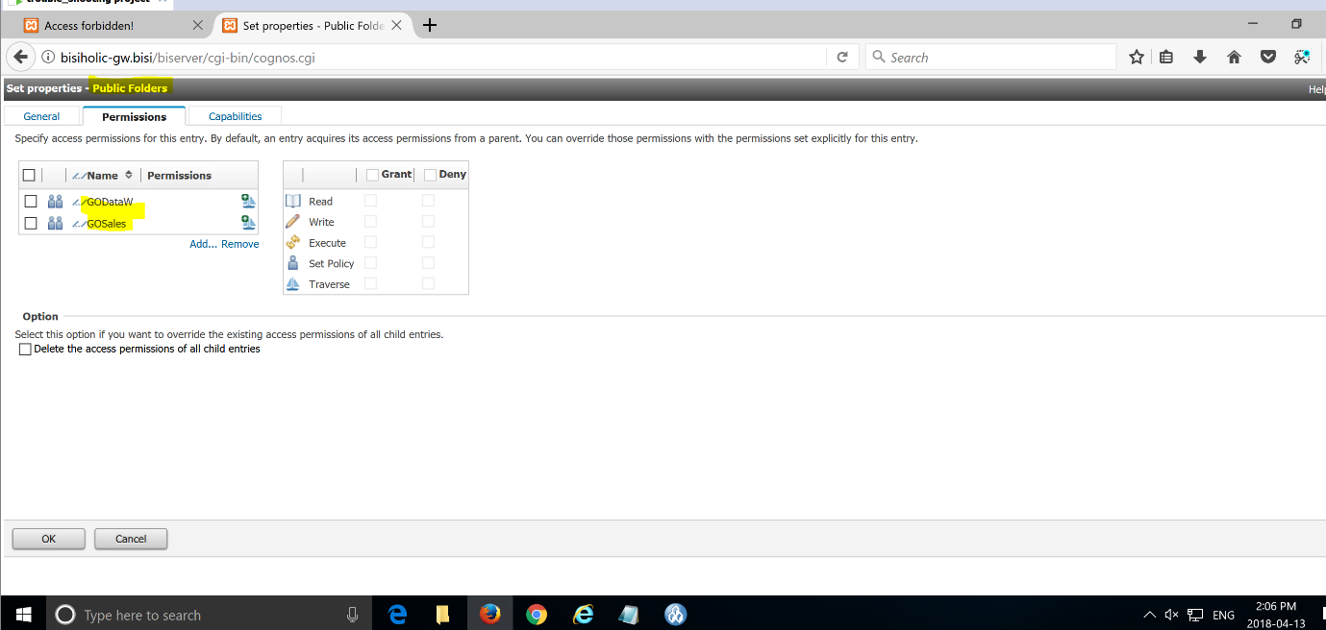

### Go Data Warehouse Query - permissions

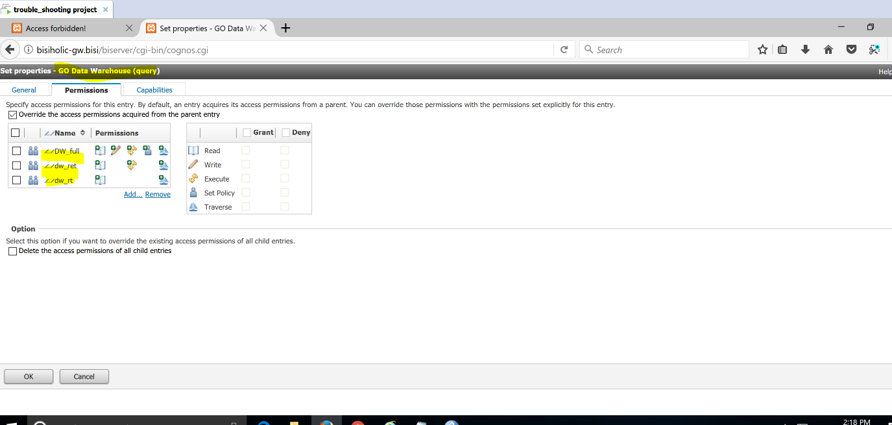

### Go sales query - permissions

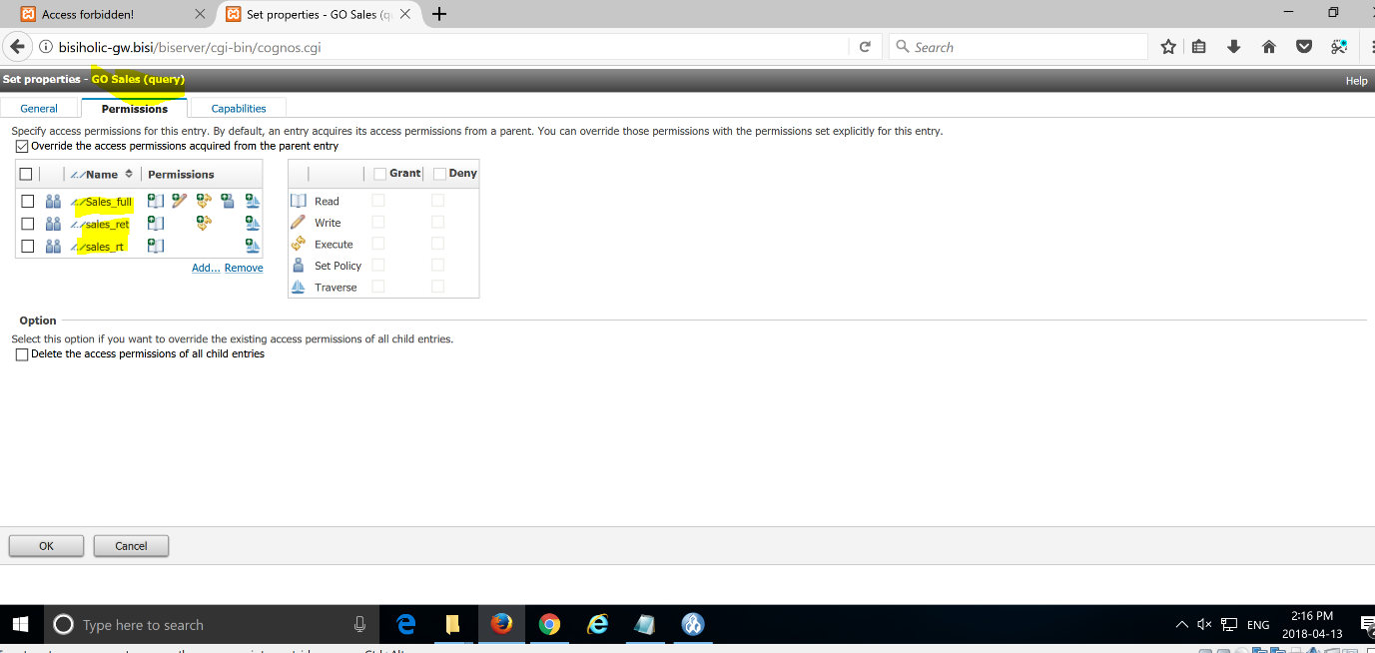

### Go sales Analysis permissions

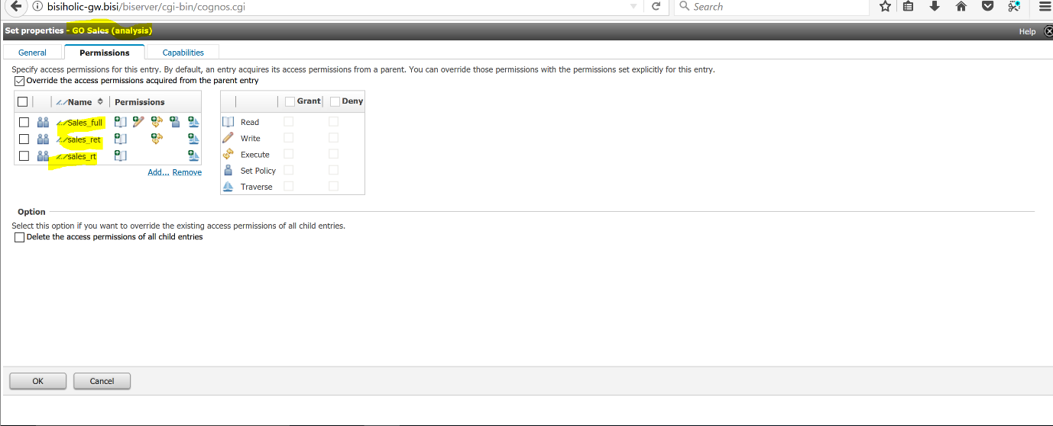

### Go Data Warehouse Analysis Permissions

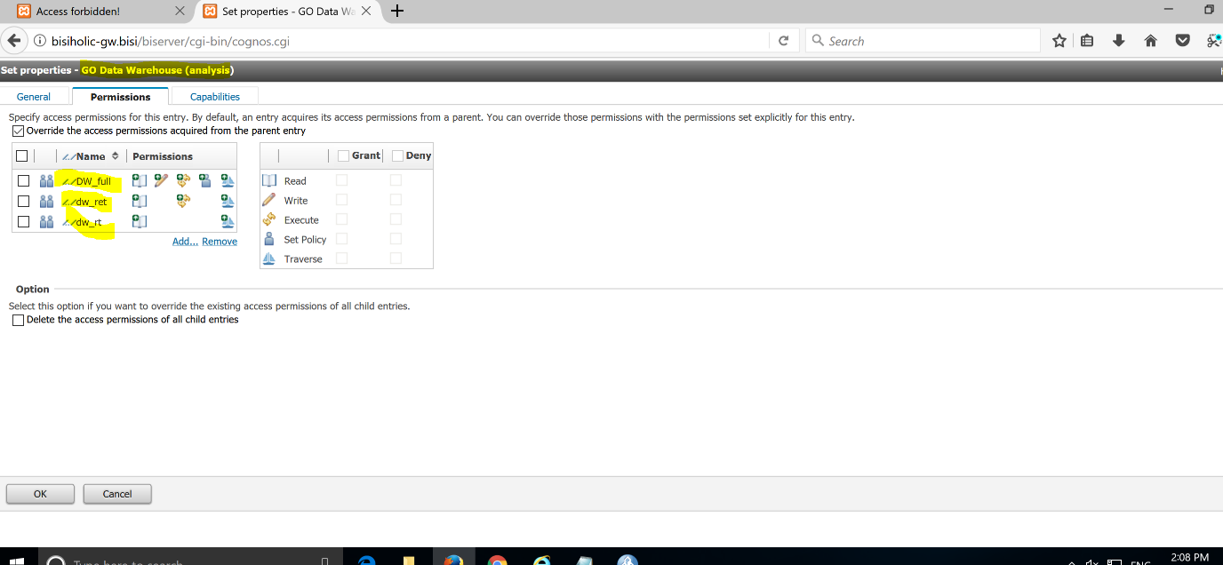

# Only the appropriate services are running on each of the components. For example:

## Front Dispatchers only runs the services it requires to perform its functions.

### FD1 Services:

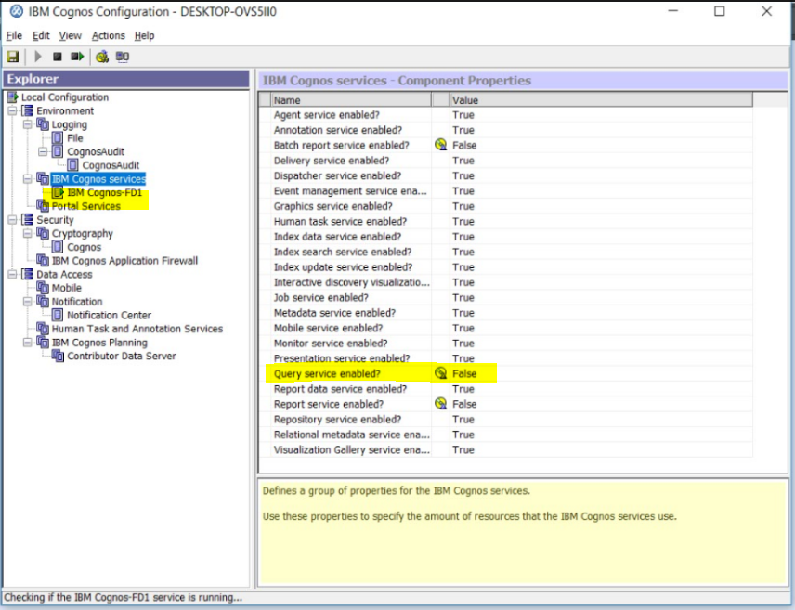

### FD2- Services

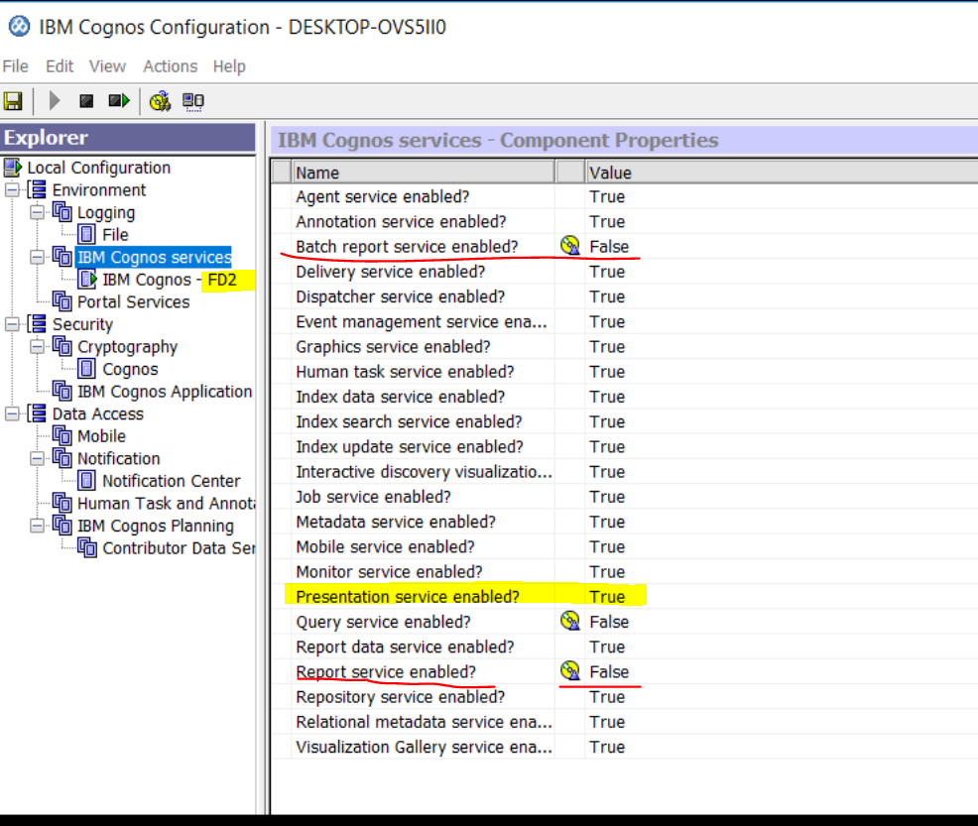

## Query services disabled on all components.

### Query services disabled – App1

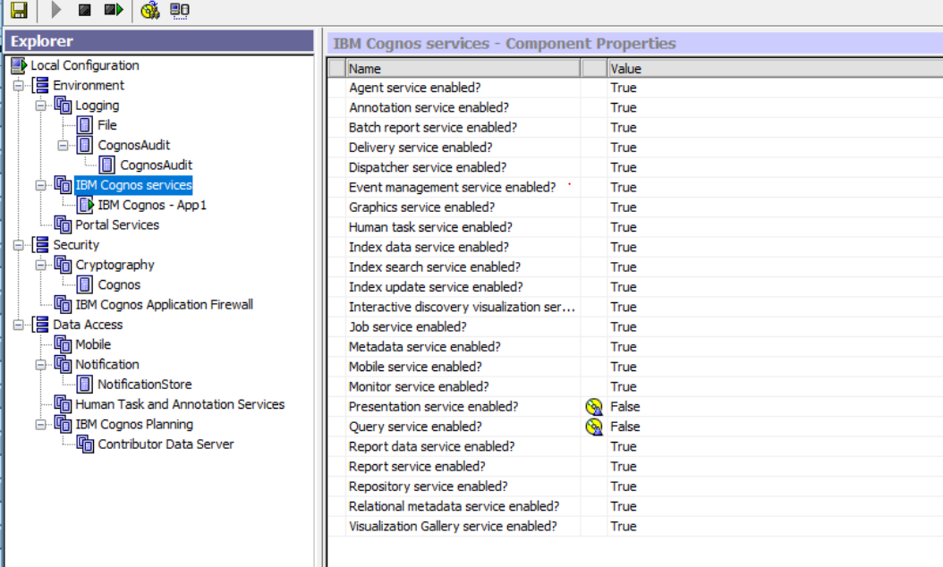Query services disabled – App2

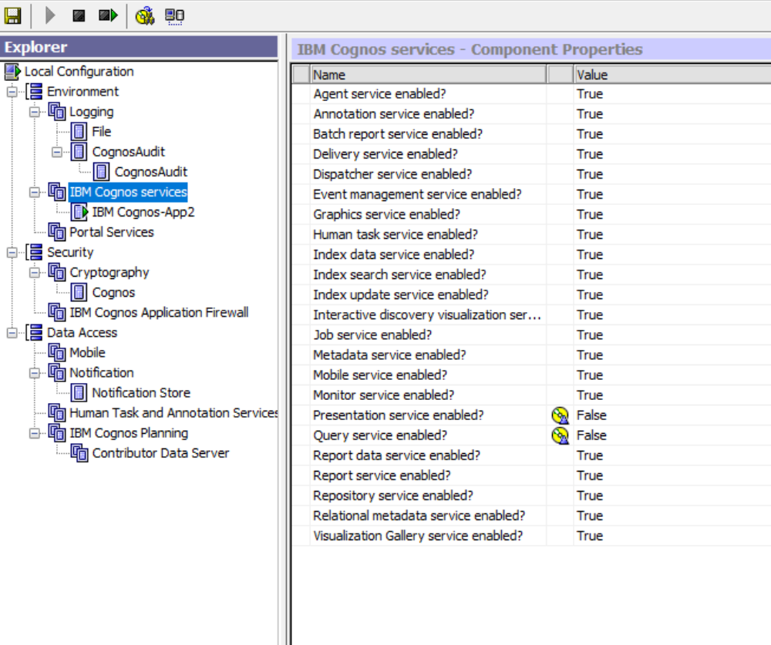

### Query services disabled – FD1

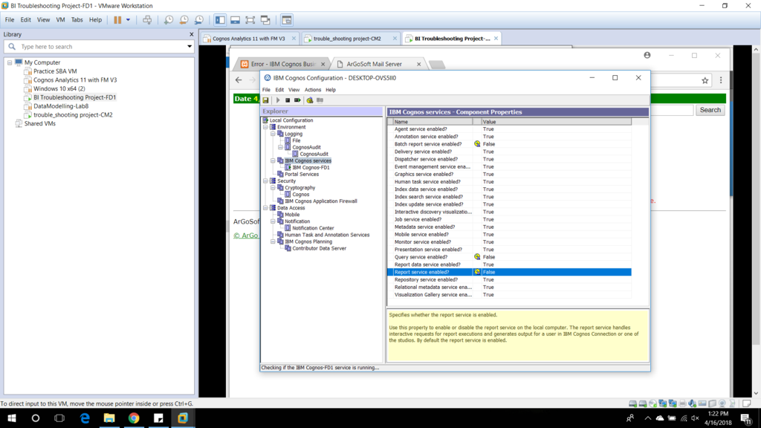

## Application servers do not run the Presentation Services.

### APP1- Services

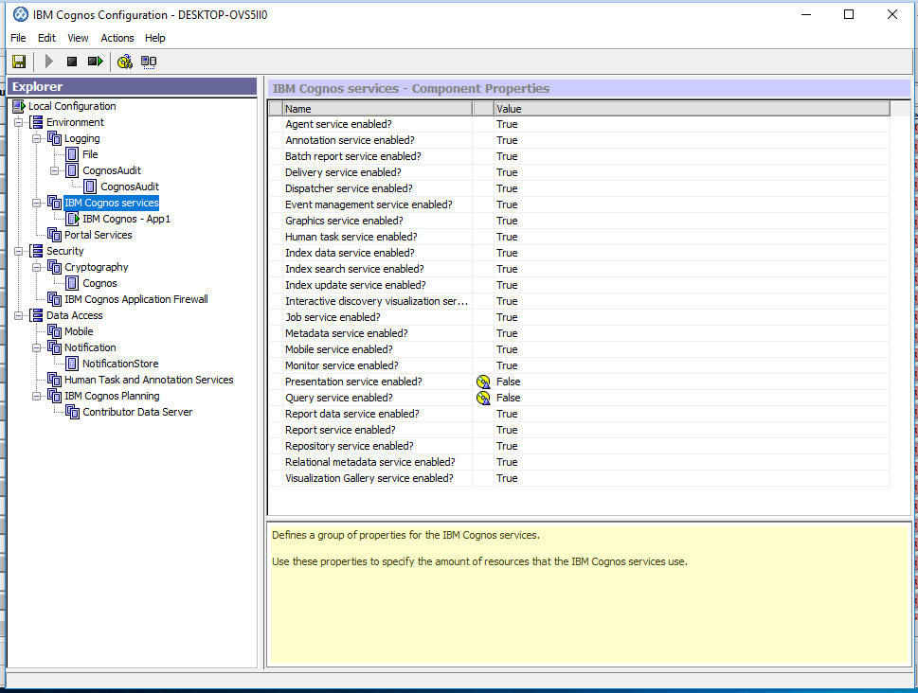

### APP2- services



# Fault Tolerance – 4 points

## Both CMs need to be configured identically such that they enforce the same level of security and offer the same name spaces for authentication purposes.

The system must be able to recover from failures in the following components:

## Fault Tolerance : Content Manager

### P2plbDiag with CM1 down and Cm2 up



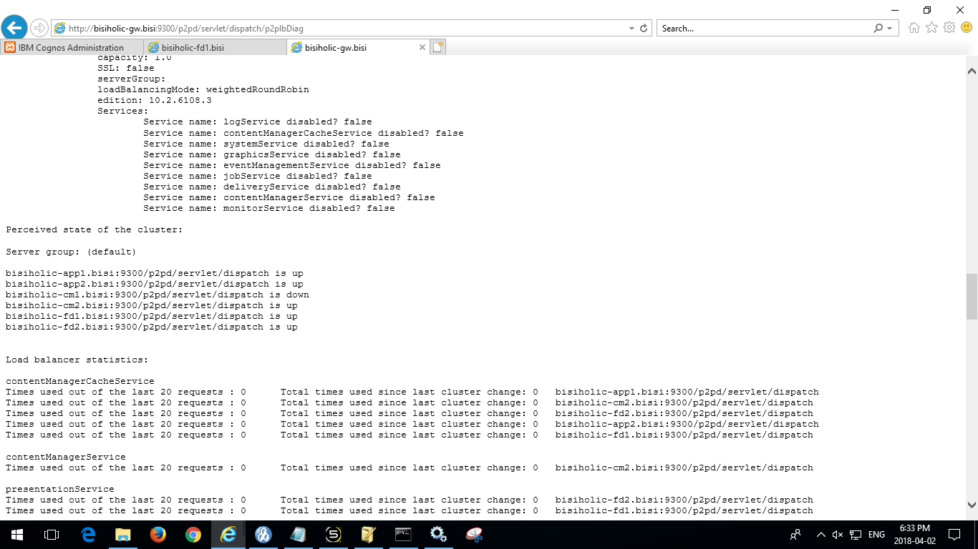

CM1 is unavailable – System is working

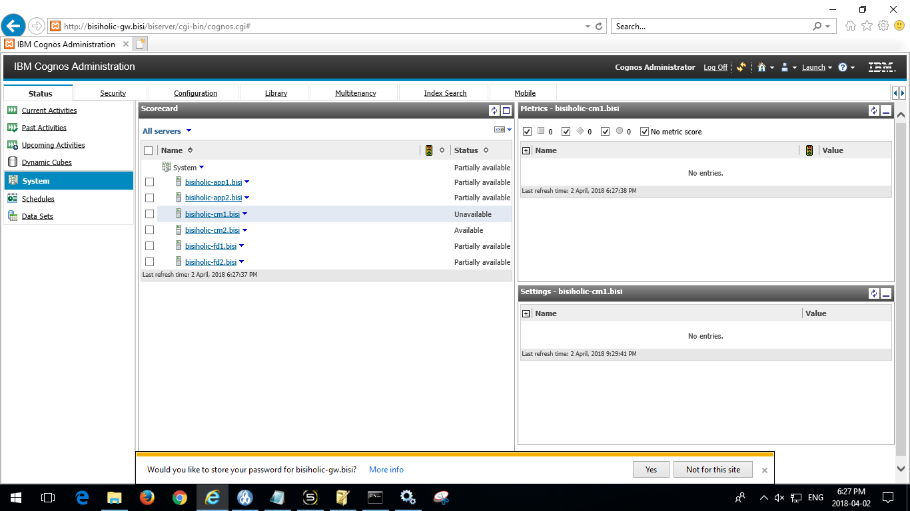

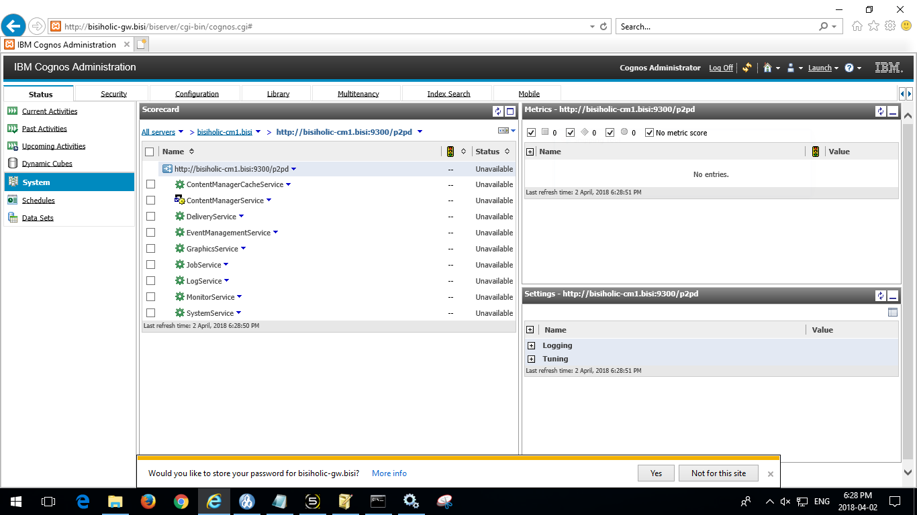

Cm2 is the active CM

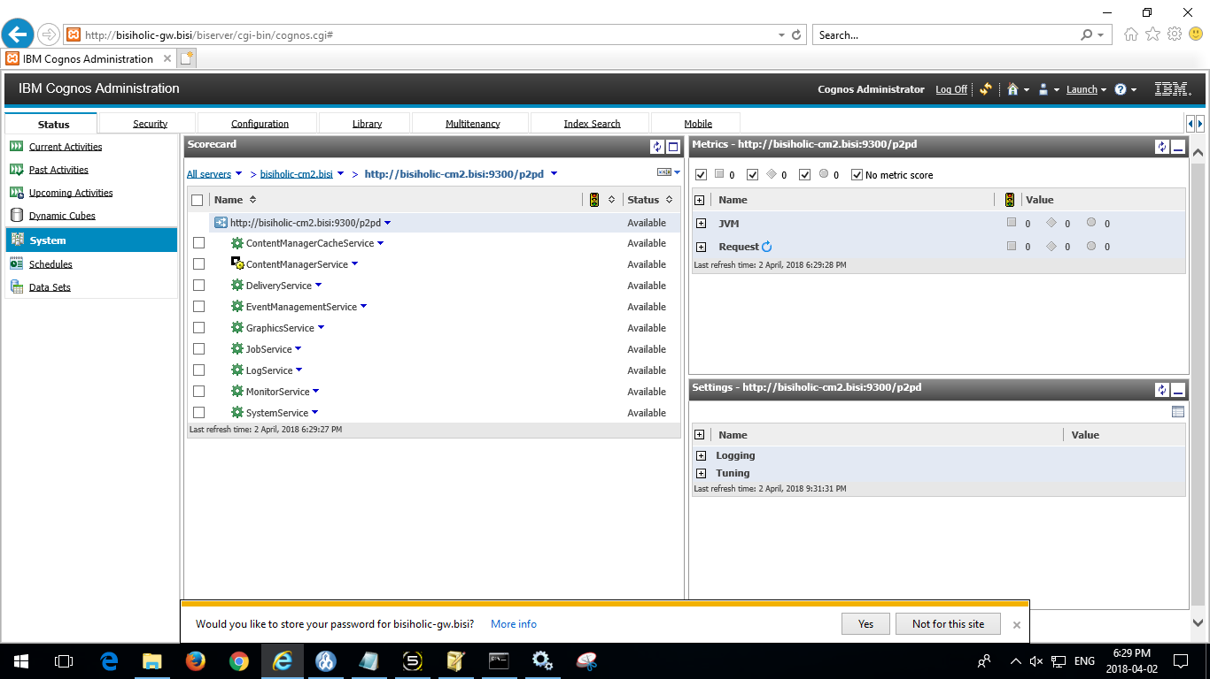

### P2plbDiag with CM1 recovering ( CM2 is the active CM, Cm1 is the Standby)



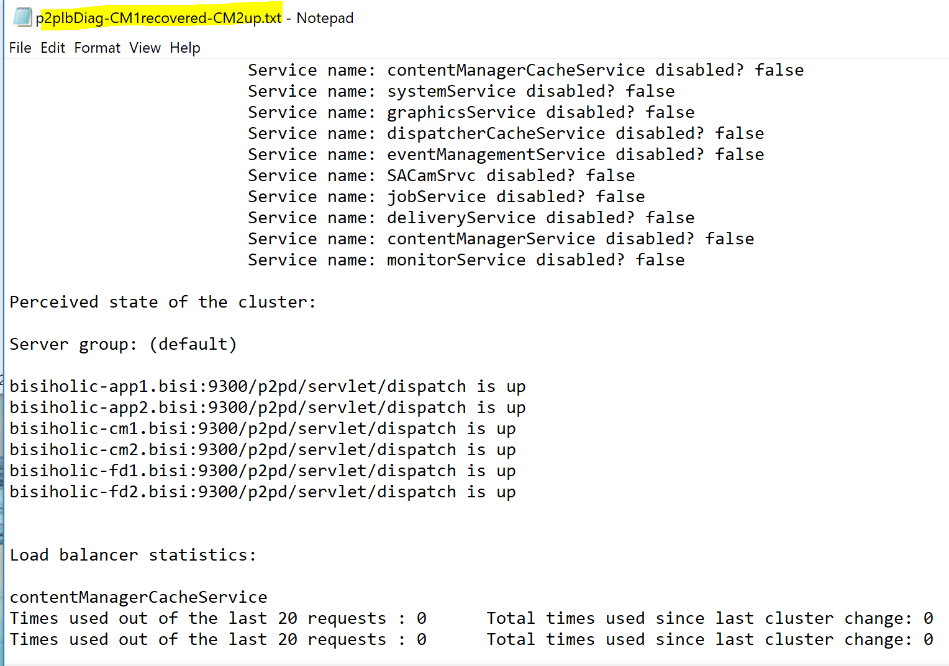

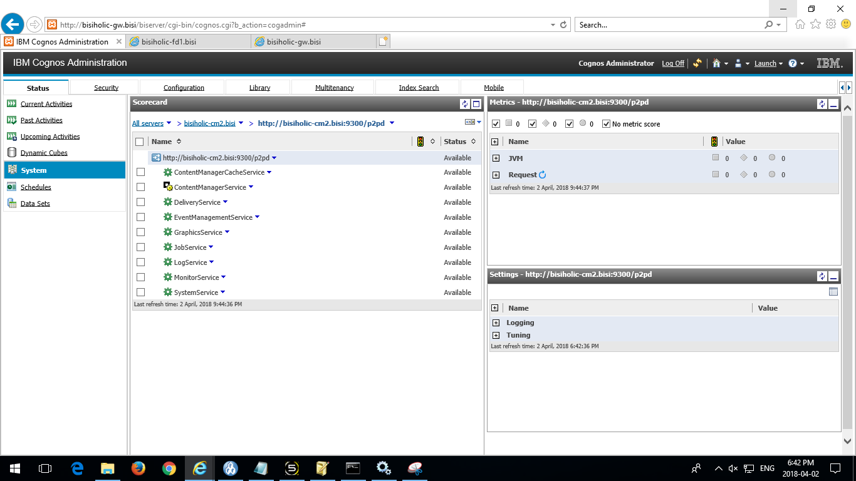

## Fault Tolerance : Front Dispatcher

### P2plbDiag with FD1 down, FD2 is up



### FD2 is the active front Dispatcher

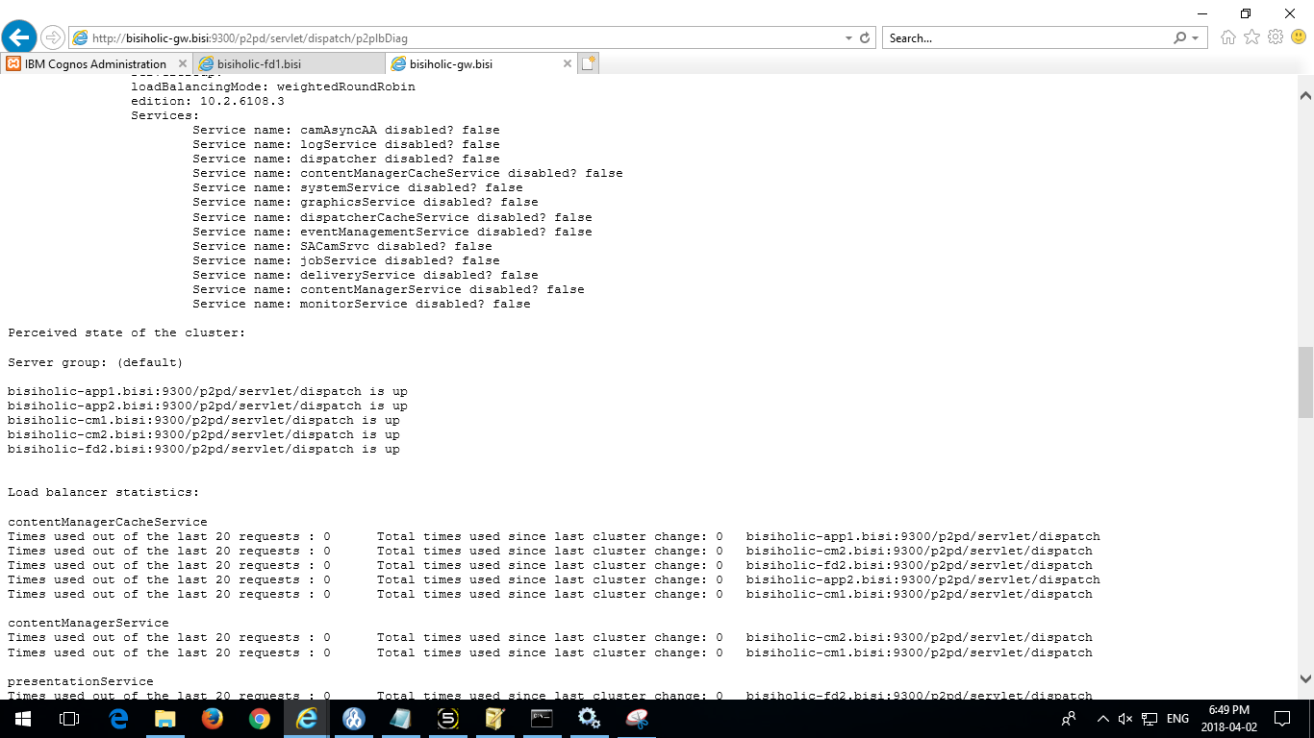

### System is working, FD1 is unavailable

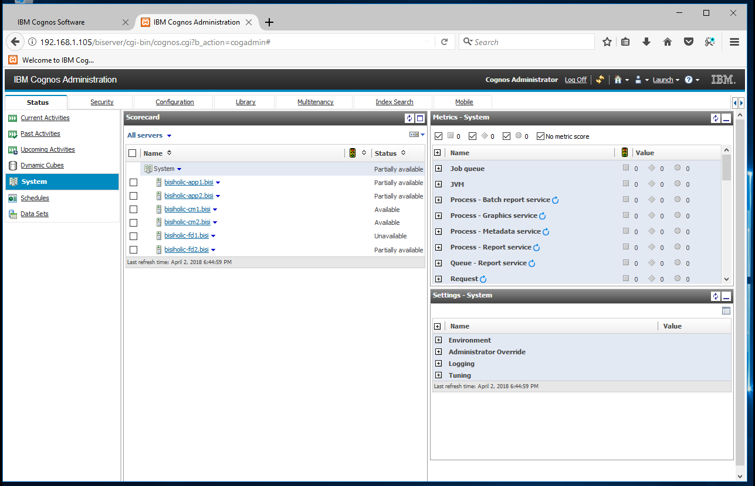

# CM1 & CM2 Same functionality and security

Each component of a group must offer the same functionality and security. For example (not an exhaustive list):

## CM1 Configuration:

**CM1-Environment ( Update)**

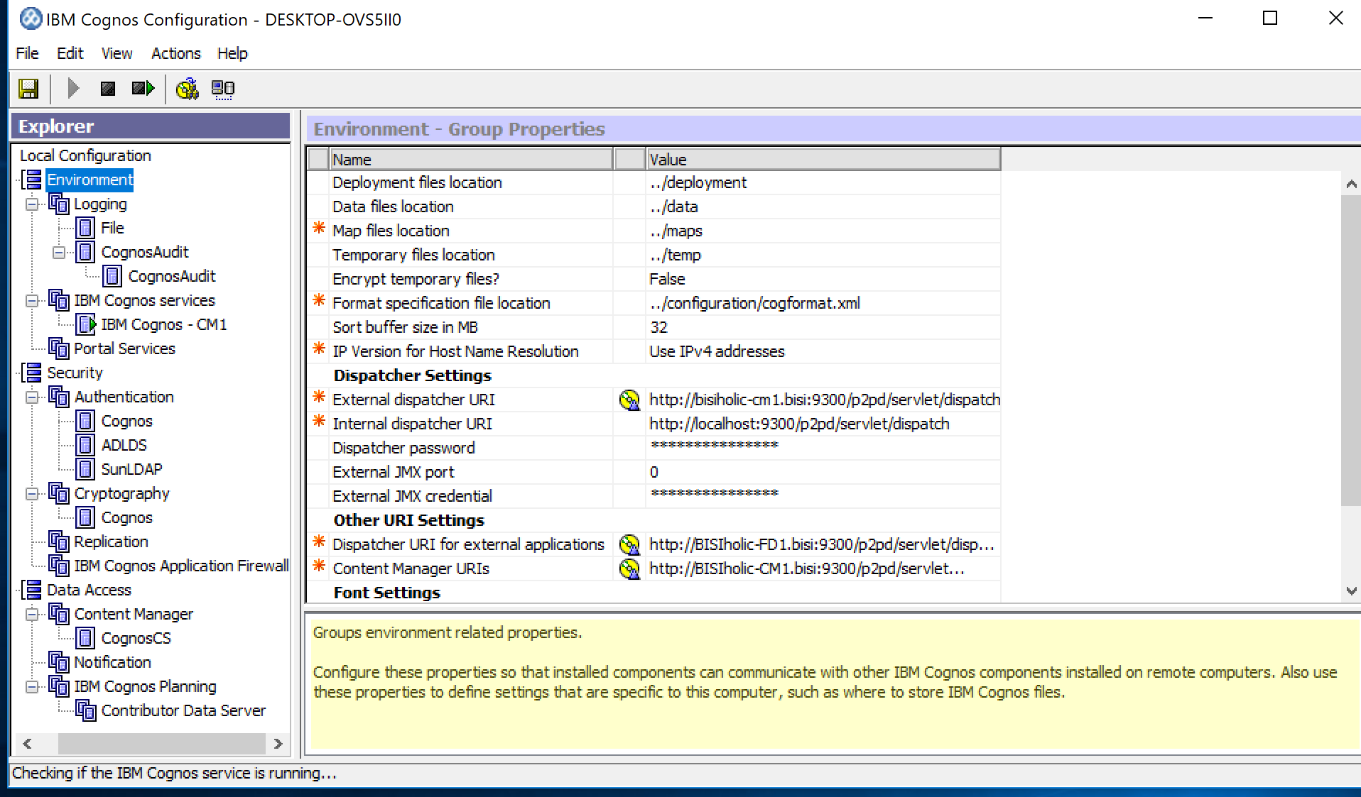

**CM1-ADLDS**



**CM1-Cognos Authentication – Allow anonymous**

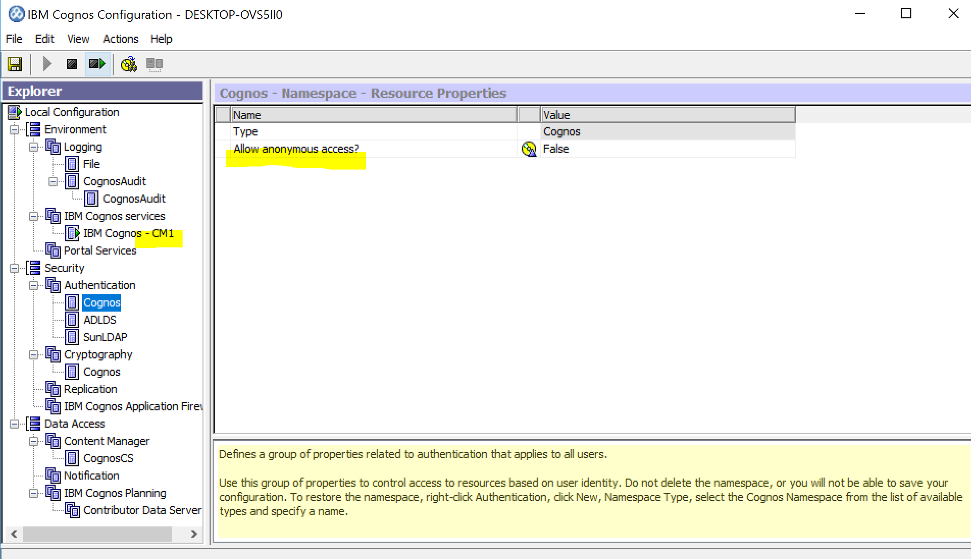

**CM1-Audit**

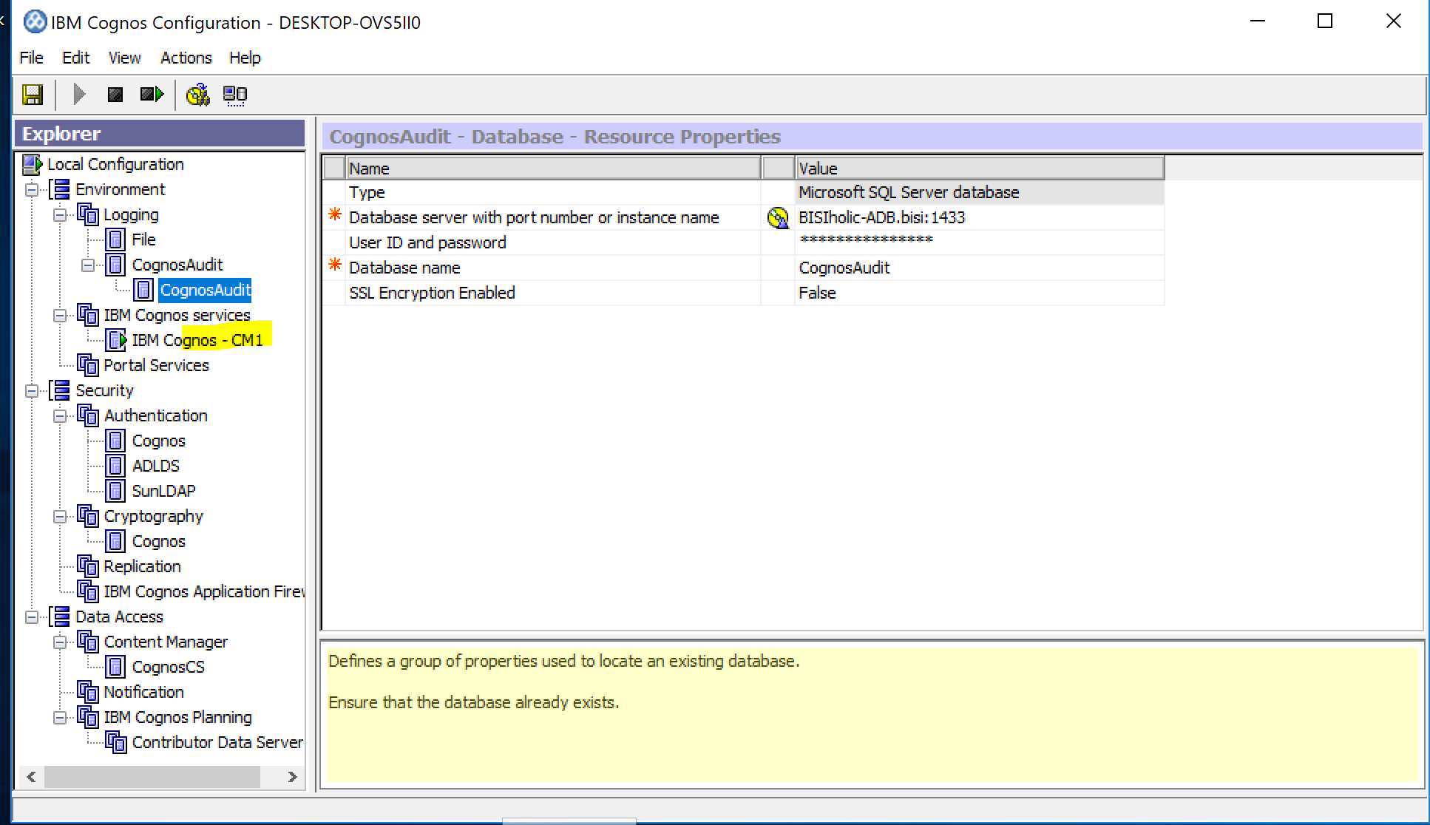

**CM1- SUNLDAP**

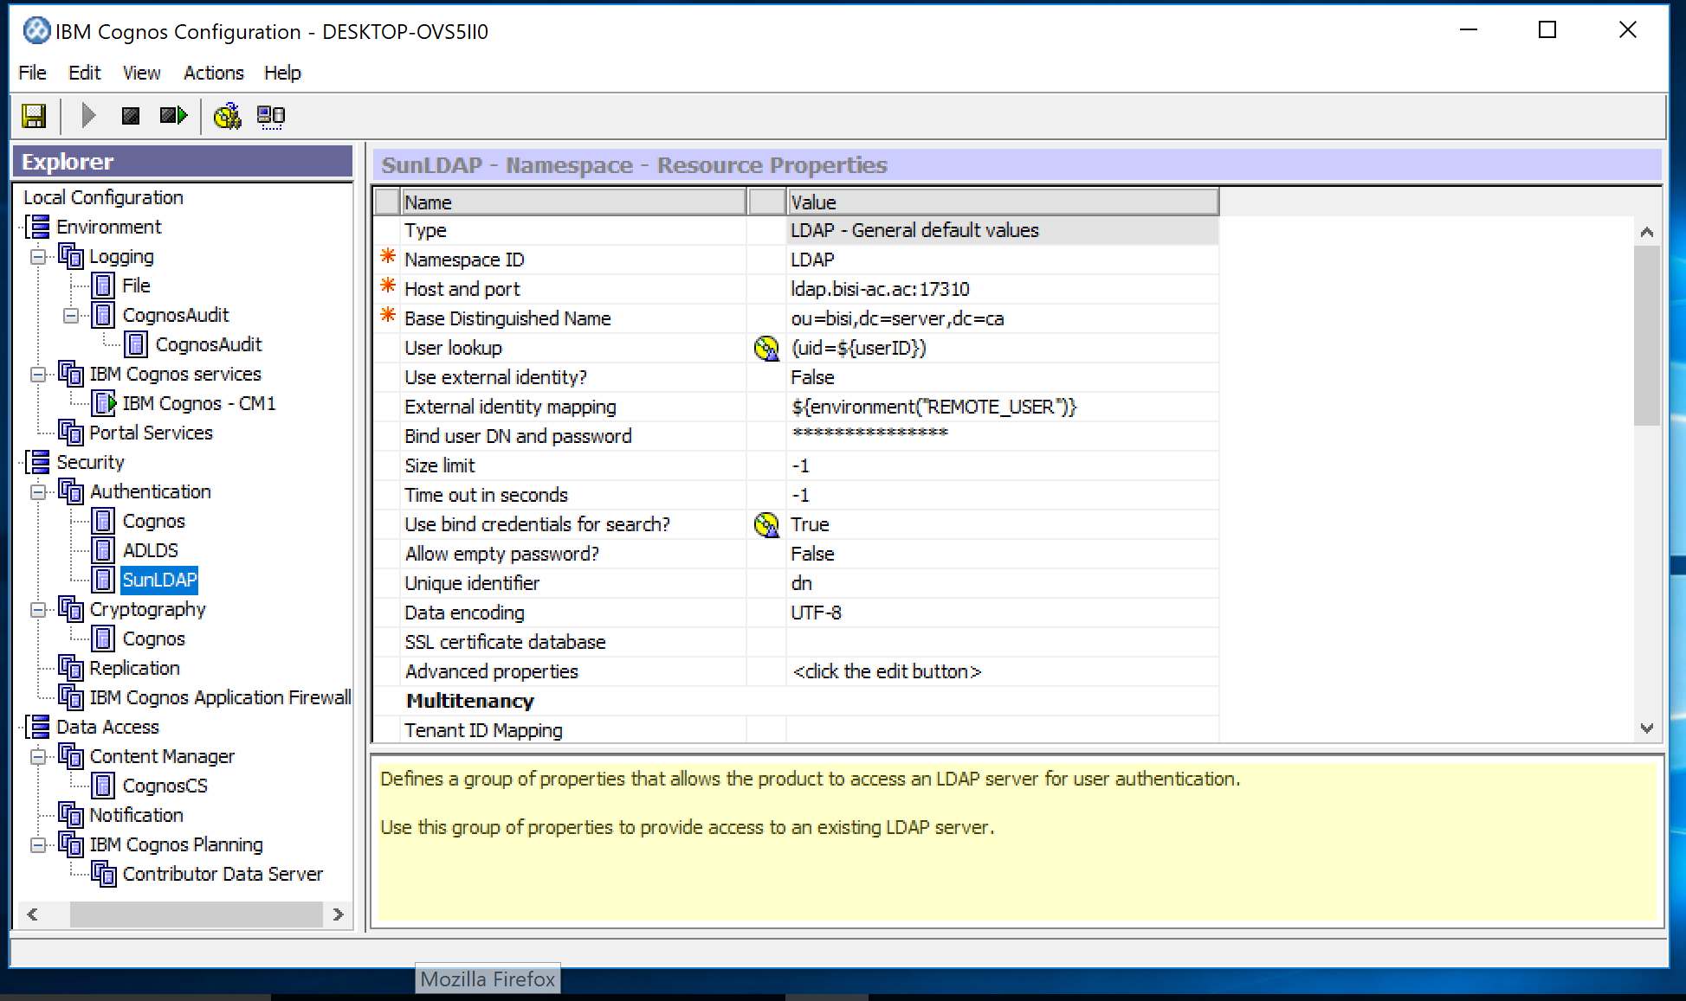

**CM1-Content Store**

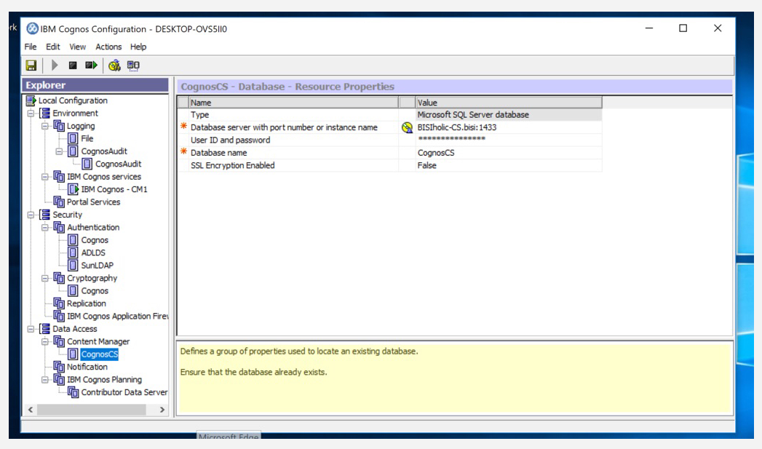

## CM2 Configuration:

**CM2-Environment**

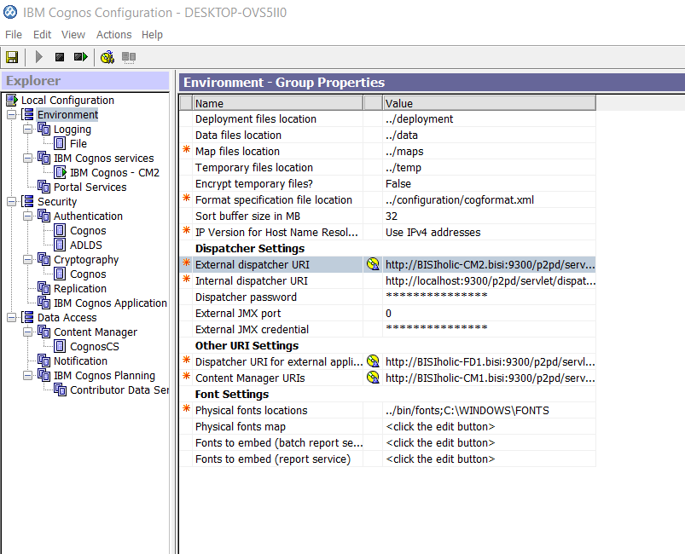

**CM2-ADLDS**



**CM2 – Notification**

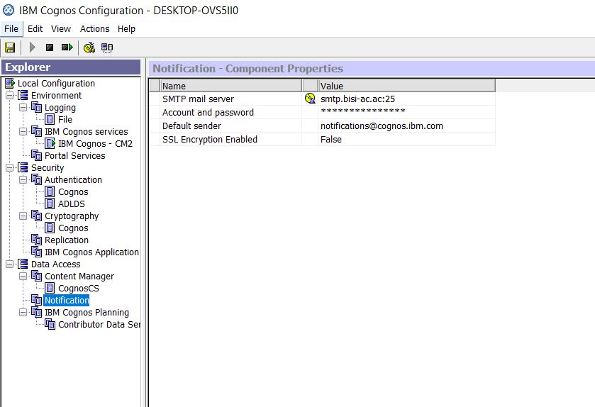

**CM2-Cognos Authentication**



**CM2-SUNLDAP**



**CM2- Audit**



**CM2-Content Store**

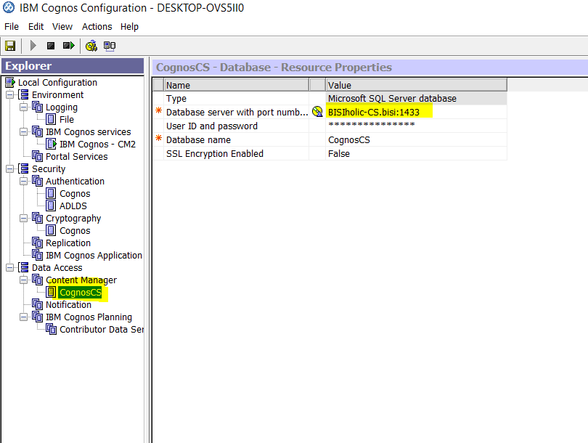

# Basic Security – 4 points

Do NOT use administrator privileged accounts such as sa or root or system accounts. Create service accounts that have no more than the necessary privileges.

**Cognos CS User ( Audit DB)**

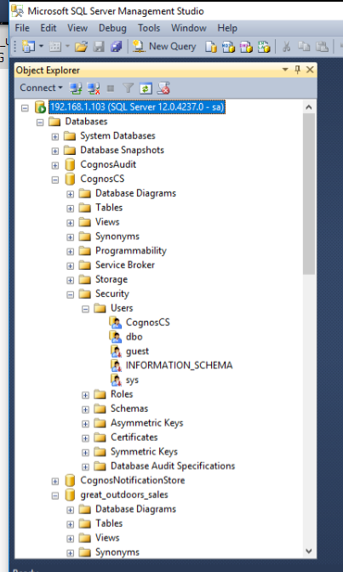

**GosalesBI User – Query DB**

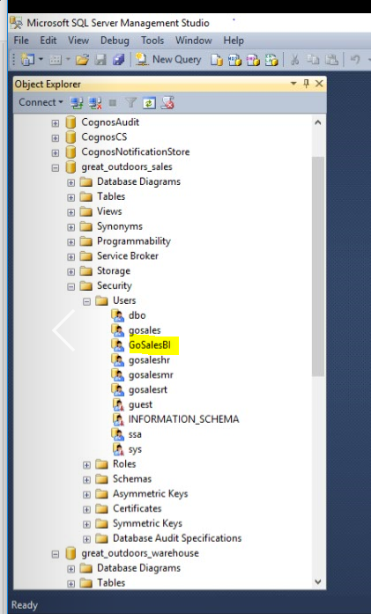

**GosalesDWBI User - Query DB**

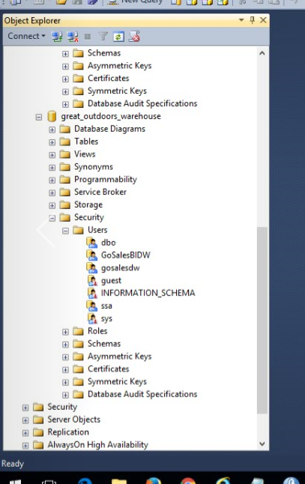

# Documentation – 2 points

Print a copy of your logical architecture diagram that must include the following information for each component:

* Component function
  + FD, CM, CS, Web/GW, App Server etc
* DNS name and port
* IP address
* Team member hosting the component

## Print the system specs summary:

* CPU model/make
  + # of cpus
  + # of cores
* RAM
* Host OS

|  |  |  |  |  |  |
| --- | --- | --- | --- | --- | --- |
| Name | Role | RAM (GB) | Base Speed | Sockets | Virtual Processors |
| Rola | Gateway | 8.57 | 2.59 | 1 | 2 |
| Rola | FD1 | 8.57 | 2.59 | 1 | 2 |
| Carlos | App1 | 7 | 2.90 | 1 | 2 |
| Moustapha | CM2 | 4 | 2.6 | 1 | 4 |
| Mia | CM1 | 4 | 2.39 | 1 | 2 |
| Ahmad | App2 | 4 | 2.81 | 1 | 2 |

## Print a copy of your logical architecture diagram

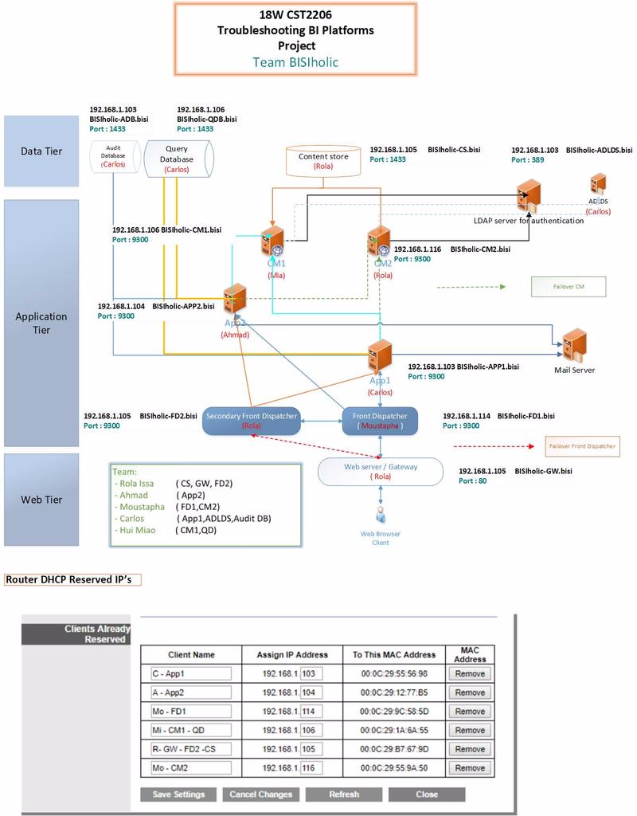

## Please provide the list of LDAP accounts.

### Users in Sun-LDAP

#### Ahmad, Carlos added



#### Mia, Rola, Moustapha



# Print a copy of the hosts file for the CM and FD.

## CM1 Hosts file

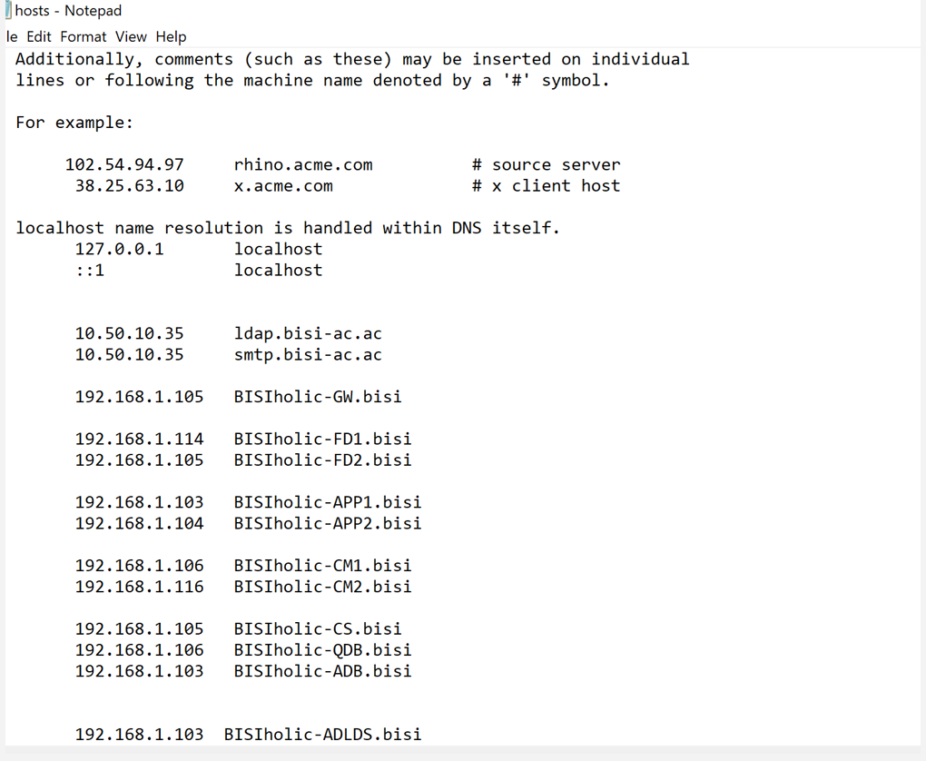

## CM2 – Hosts File

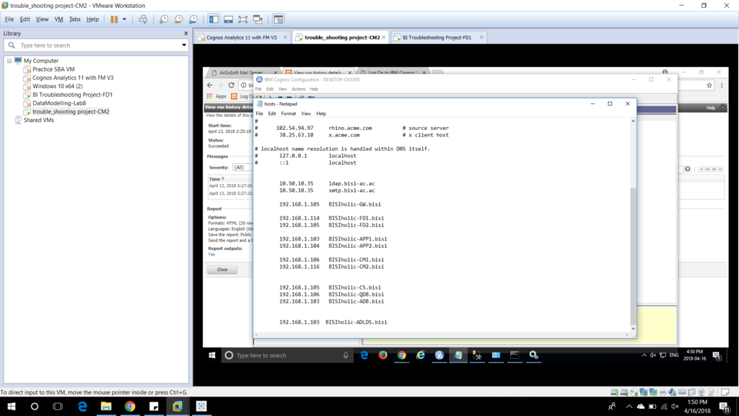

## FD1 Hosts File

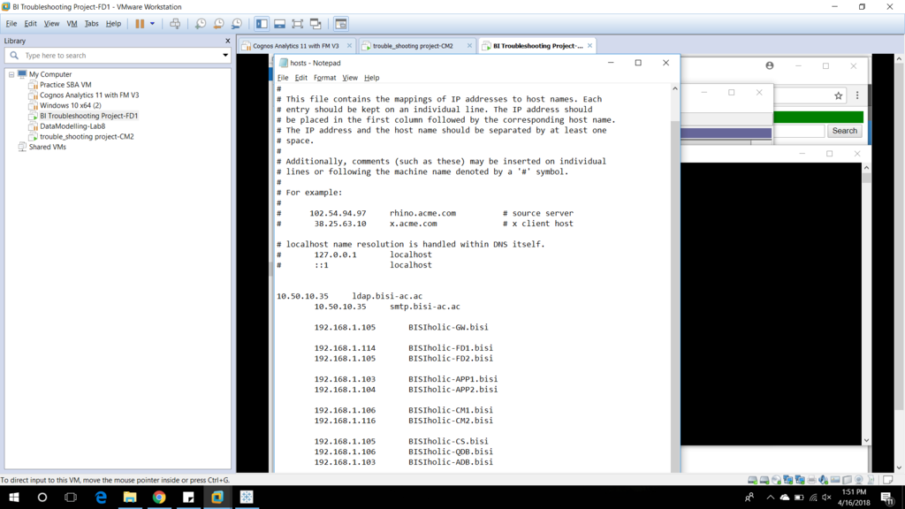

## FD2 Hosts File

